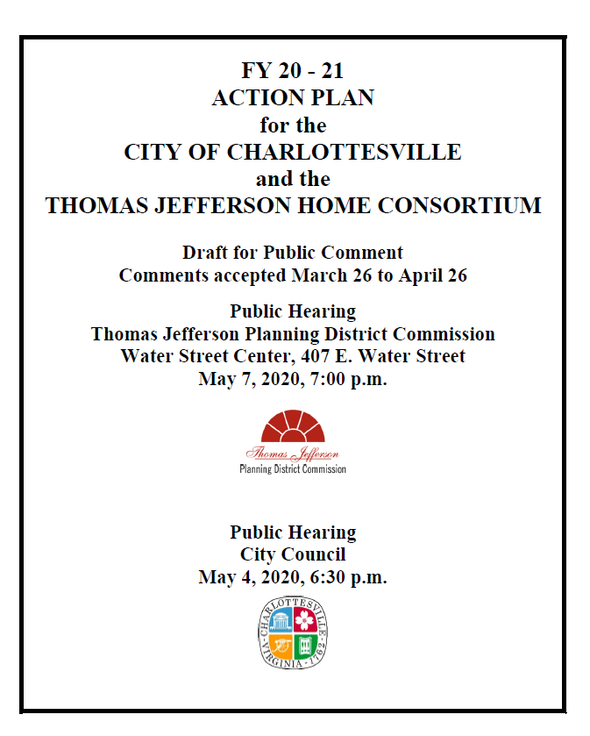

Executive Summary

AP-05 Executive Summary - 91.200(c), 91.220(b)
1. Introduction
The Consolidated Plan for 2018-2022 set forth an overall plan to support community development needs, including housing needs, in the Thomas Jefferson Planning District and in the City of Charlottesville. The Action Plan for FY 2020-2021 re-affirms the goals expressed in the region’s Consolidated Plan, which was developed and adopted in May 2018. The Consolidated Plan is a five-year document that guides the specific activities developed annually through the Action Plan. Both the Consolidated Plan and the annual Action Plan guide the use of federal Community Development Block Grant (CDBG) funds received annually by the City of Charlottesville and the federal HOME funds received annually by the Thomas Jefferson HOME Consortium. Consortium members include the City of Charlottesville and the counties of Albemarle, Fluvanna, Greene, Louisa, and Nelson.
The member governments of the Thomas Jefferson Planning District agreed on an equal share basis of HOME funds available to each participating government (with towns included with their respective counties) with the exception of 15% of the total HOME funds, which are reserved for the Community Housing Development Organization (CHDO) set aside. The CHDO funds are rotated among the participating localities. The City of Charlottesville has been designated the lead agency for the HOME Consortium and the Thomas Jefferson Planning District Commission the designated Program Manager for the Consortium.
This Action Plan identifies specific activities to be undertaken with the funds during the program year from July 1, 2020 to June 30, 2021 as a means of fulfilling the goals stated in the Consolidated Plan.
The Coronvirus Aid, Relief, and Economic Security Act (CARES Act), Public Law 116-136, signed by President Trump on March 27, 2020, to respond to the growing effects of the historic public health crisis makes available Community Development Block Grant funds to be used to prevent, prepare for, and respond to the coronavirus (COVID-19).
2. Summarize the objectives and outcomes identified in the Plan
This could be a restatement of items or a table listed elsewhere in the plan or a reference to another location. It may also contain any essential items from the housing and homeless needs assessment, the housing market analysis or the strategic plan.
. The objectives identified in the one year Action Plan for FY 20-21 are:
- Provide decent housing: Activities focus on housing programs where the purpose of the activity meets individual, family, or community needs;
- Establish and maintain a suitable living environment: Activities designed to benefit families, individuals, and communities by addressing their living environment; and
- Create Economic Opportunities: Activities related to economic development, commercial revitalization, or job creation.
The identified objectives are combined with two performance outcome categories for FY 19-20:
- Accessibility/availability: Activities that make services, infrastructure, public services, public facilities, housing, or shelter available or accessible to low and moderate-income people, including persons with disabilities.
- Affordability: Activities that provide affordability in a variety of ways in the lives of low and moderate-income people. It can include the creation or maintenance of affordable housing, basic infrastructure hook-ups, or services such as transportation or day care.
The objectives identified in the CARES Act:
- Community Development Block Grant funds to be used to prevent, prepare for, and respond to the coronavirus (COVID-19)
3. Evaluation of past performance
This is an evaluation of past performance that helped lead the grantee to choose its goals or projects.
The City and the HOME Consortium have made an impact with CDBG and HOME funds. Prior to updating the Consolidated Plan, staff performed a self-evaluation of the full scope of the 5-year plan, aggregating accomplishments recorded in the annual CAPER reports for the five years of the Consolidated Plan. The purpose of the self-assessment was to set realistic goals, based on what has been achievable in the past given a certain level of funding. The evaluation revealed that some activities fell short of the goals in the previous Consolidated Plan, while others greatly exceeded the goals.
In general, with the exception of not meeting the strategic plan goal for affordable rental assistance, the City exceeded its CDBG goals. The City exceeded its goals for supporting job improvement, conducting training sessions related to job improvement, supporting homeless and transition to independence, supporting programs to assist persons with special needs, and support for operating a transitional home. The Priority Neighborhood project outcomes lagged due to a multi-year, multi-phased project approach, however, all outcomes will be reported in the following year’s CAPER (2019-2020). All FY 19-20 activities tied to the 2018-2022 Consolidated Plan will be reported in the FY 2019-2020 CAPER.
For HOME, downpayment assistance and other activities designed to promote first-time homeownership, homeowner rehabilitation, and the creation of new homeowner units did not meet its strategic plan goals. On the other hand, creation of new rental units exceeded projected outcomes. The Consolidated Plan establishes broad 5-year goals, but the annual Action Plans allow the City of Charlottesville and the HOME Consortium the ability to adapt to current market conditions and changing needs. Fiscal Year 19-20 outcomes are currently unknown and will be reported out on in the CAPER report due in September. Redevelopment of Public Housing has not yet began as the planning process is currently ongoing.
A commitment of City resources is often the catalyst used by community-based organizations to leverage private dollars for even greater impact. With the financial commitment of the City, organizations are greatly strengthened in their ability to obtain donations from the community, from foundations, and the private sector. Additionally, City funds are often used as last in “gap financing” to support important efforts after an organization’s fundraising capacity has been reached. Annual performance, projects funded, and entitlement resources expended are located in each annual CAPER.
4. Summary of Citizen Participation Process and consultation process
Summary from citizen participation section of plan.
Citizen participation was a central component of the Consolidated Plan update, completed in August 2018. This process established the goals and priorities for the Consolidated Plan, which continues to inform the annual Action Plans. For this Action Plan, a draft for public comment was made available on March 27, 2020 for a 30-day public comment period. An advertisement on the availability of the draft and the comment period appeared in the Friday, March 27, 2020 issue of the Daily Progress, the newspaper of general circulation in the region. The draft plan for public comment was also distributed by e-mail: Agencies and Organizations - The Charlottesville Health Department of the Thomas Jefferson Health District, United Way, Independence Resource Center, County of Albemarle, Salvation Army, Region Ten Community Services, Monticello Area Community Action Agency, Charlottesville Redevelopment and Housing Authority, Albemarle Housing Improvement Program, Piedmont Housing Alliance, Jefferson Area Board For Aging, County of Albemarle Housing Office, Public Housing Association of Residents, On Our Own-Drop-In Center, and Charlottesville/Albemarle Legal Aid Society; Local Media - The Daily Progress, Fluvanna Review, Greene County Record, The Central Virginia, and Cville Weekly; Neighborhood Associations – Belmont-Carlton, Blue Ridge Commons, Burnett Commons, Fifeville, Forest Hills, Fry’s Spring, Greenbrier, Jefferson Park Avenue, Johnson Village, Kellytown, Lewis Mountain, Little High, Locust Grove, Martha Jefferson, Meadows, Meadowbrook Hills/Rugby, North Downtown, Orangedale, Ridge Street, Rose Hill, Starr Hill, University, Venable, Westhaven, Willoughby, Woodhaven, Woolen Mills and 10th and Page.
A public hearing was held at the Thomas Jefferson Planning District Commission’s (TJPDC’s) regular meeting on May 7, 2020. The draft plan was posted on the TJPDC web site and an article on the availability of the plan was included in TJPDC’s special newsletter via email on April 11, 2020; reaching an audience of approximately 1,200 people across the region. The Regional Housing Directors Council is a major partner in the development of the Action Plan, provided input on actions to be undertaken and reviewing the plan at its regular monthly meetings during plan development. The City Council held a public hearing on May 4, 2020 and adopted the Action Plan on May 18, 2020
5. Summary of public comments
This could be a brief narrative summary or reference an attached document from the Citizen Participation section of the Con Plan.
During the May 4, 2020 City of Charlottesville City Council virtual public hearing, the following comments were received:
Public Housing Association of Residents (PHAR) spoke during the May 4 City Council Public Hearing. The following comments were recommended:
- A greater empahsis on Section 3 with CDBG projects
- Utilization of Priority Neighborhood funds to coordinate with public housing projects in the Priority neighborhood target area.
Resident comments from the May 4 City Council Public Hearing are included below:
- Utilization of the priority neighborhood funding for housing purposes, not public infrastructure projects

During the May 7, 2020 Thomas Jefferson Planning District Commission meeting no comments were received.
Additional public comments can be found in AP-12.

COVID
Citizen participation was a central component of the Consolidated Plan update, completed in August 2018. This process established the goals and priorities for the Consolidated Plan, which continues to inform the annual Action Plans. For this Action Plan Amendment, a draft for public comment was made available on May 4, 2020 for a 5-day expedited COVID public comment period. An advertisement on the availability of the draft and the comment period appeared in the May 4, 2020 issue of the Daily Progress, the newspaper of general circulation in the region. The draft plan for public comment was also distributed by e-mail: Agencies and Organizations - The Charlottesville Health Department of the Thomas Jefferson Health District, United Way, Independence Resource Center, County of Albemarle, Salvation Army, Region Ten Community Services, Monticello Area Community Action Agency, Charlottesville Redevelopment and Housing Authority, Albemarle Housing Improvement Program, Piedmont Housing Alliance, Jefferson Area Board For Aging, County of Albemarle Housing Office, Public Housing Association of Residents, On Our Own-Drop-In Center, and Charlottesville/Albemarle Legal Aid Society; Local Media - The Daily Progress, Fluvanna Review, Greene County Record, The Central Virginia, and Cville Weekly; Neighborhood Associations – Belmont-Carlton, Blue Ridge Commons, Burnett Commons, Fifeville, Forest Hills, Fry’s Spring, Greenbrier, Jefferson Park Avenue, Johnson Village, Kellytown, Lewis Mountain, Little High, Locust Grove, Martha Jefferson, Meadows, Meadowbrook Hills/Rugby, North Downtown, Orangedale, Ridge Street, Rose Hill, Starr Hill, University, Venable, Westhaven, Willoughby, Woodhaven, Woolen Mills and 10th and Page.
Citizens had the opportunity for public comment during the CDBG/HOME Taskforce regular virtual meeting on June 11 and June 15, 2020. Citizens also had the opportunity for public comment during the virtual Planning Commission meeting on July 14, 2020. The draft plan was posted on the TJPDC web site and an article on the availability of the plan was included in TJPDC’s special newsletter via email on April 11, 2020; reaching an audience of approximately 1,200 people across the region. The Regional Housing Directors Council is a major partner in the development of the Action Plan, provided input on actions to be undertaken and reviewing the plan at its regular monthly meetings during plan development. The City Council held a public hearing on May 4, 2020 and adopted the Action Plan on May 18, 2020
6. Summary of comments or views not accepted and the reasons for not accepting them
Each year, City Council sets priorities on CDBG/HOME funds and their usage. Section 3 was named one of the City Council Priorities in 2019 before the acceptance of CDBG/HOME applications. Priority Neighborhood projects get deliberated with the Priority Neighborhood taskforce. All potential projects undergo extensive community engagement to gauge the community priorities before finalizing a project.
HOME funds can be used for housing within four basic program types:

1) Homebuyer assistance,
2) Rehabilitation for owner-occupants;
3) Rental housing production, and
4) Tenant-based rental assistance (TBRA).

In order to utilize HOME funds for TBRA, the Consolidated Plan must address why it needs a TBRA program, whether it is exercising any preferences in its TBRA, and certify that TBRA is essential to its housing strategy. The current HOME Consolidated Plan for PY18-22 does not include TBRA as part of its housing strategy. HUD’s Building HOME training manual indicates that TBRA may be particularly effective in communities with high vacancy rates, where the PJ wants to make units affordable. Our region has very low vacancy rates.
The HOME statute specifies that rehabilitation of both rental and homeowner units should be given preference over other types of eligible uses of HOME funds.
Actions to affirmatively further fair housing are included in the Action Plan in a table showing one-year actions to address impediments to fair housing choice.
The City and region are committed to taking ongoing actions to affirmatively further fair housing.
7. Summary
This one-year Action Plan is consistent with the goals established in the five-year Consolidated Plan.
The Consolidated Plan contains data and narrative to establish the current and anticipated needs, a description of the current and anticipated market context within which any activities would be conducted, and a strategic plan designed to meet identified needs with the anticipated funding available. The plan will govern housing and community development actions undertaken by the City of Charlottesville and the HOME Consortium between 2018 and 2023. The added Amendment includes CDBG-CV funds to prevent prepare for, and respond to the Coronavirus Pandemic.

PR-05 Lead & Responsible Agencies - 91.200(b)
1. Agency/entity responsible for preparing/administering the Consolidated Plan
The following are the agencies/entities responsible for preparing the Consolidated Plan and those responsible for administration of each grant program and funding source.
Agency Role | Name | Department/Agency
Lead Agency | CHARLOTTESVILLE

CDBG Administrator | CHARLOTTESVILLE | City of Charlottesville
HOPWA Administrator
HOME Administrator | CHARLOTTESVILLE | Thomas Jefferson Planning District Commission
HOPWA-C Administrator
Table 1 – Responsible Agencies

Narrative

Consolidated Plan Public Contact Information
Erin Atak
Grants Coordinator, City of Charlottesville
610 E. Market Street
Charlottesville, VA 22902
Email: atake@charlottesville.gov
Phone: 434-970-3182
Shirese Franklin
Planner II
Thomas Jefferson Planning District Commission
410 East Water Street/PO Box 1505
Charlottesville, VA 22902-1505
E-Mail: Sfranklin@tjpdc.org
Phone: 434-422-4822

AP-10 Consultation - 91.100, 91.200(b), 91.215(l)
1. Introduction
This section lists the agencies and organizations that have been consulted for information and direction on the Action Plan. Many of the consulting parties influenced the Action Plan, typically in the areas specific to the expertise of the organization.
Provide a concise summary of the jurisdiction’s activities to enhance coordination between public and assisted housing providers and private and governmental health, mental health and service agencies (91.215(l)).
There are a few umbrella organizations in the region that serve to bring together housing providers and human services and health agencies. The Thomas Jefferson Area Coalition for the Homeless (TJACH) is a non-profit organization that serves as the lead for the region’s Continuum of Care. The TJACH Governance Board includes housing providers, representatives from Departments of Social Services, and other human services and health agencies. The Housing Directors Council includes representatives from all HOME sub-recipients, with regular participation from the Jefferson Area Board for Aging (JABA). JABA is working with Piedmont Housing Alliance on a plan for continuing to keep Low-Income Housing Tax Credit properties affordable beyond the end of their affordability period. There are a few umbrella organizations in the region that serve to bring together housing providers and human services and health agencies. The Thomas Jefferson Area Coalition for the Homeless (TJACH) is a non-profit organization that serves as the lead for the region’s Continuum of Care. The TJACH Governance Board includes housing providers, representatives from Departments of Social Services, and other human services and health agencies. The Housing Directors Council includes representatives from all HOME sub-recipients, with regular participation from the Jefferson Area Board for Aging (JABA). JABA is working with Piedmont Housing Alliance on a plan for continuing to keep Low-Income Housing Tax Credit properties affordable beyond the end of their affordability period. The Thomas Jefferson Health District is working with the general public to inform the community of its community health plan for COVID-19.
Describe coordination with the Continuum of Care and efforts to address the needs of homeless persons (particularly chronically homeless individuals and families, families with children, veterans, and unaccompanied youth) and persons at risk of homelessness.
The Thomas Jefferson Area Coalition for the Homeless (TJACH) serves as the regional CoC. TJACH is included on e-mails, including meeting announcements, for the HOME Consortium. TJACH provided information on actions for the homeless and other special needs for inclusion in this plan. TJACH adopted a revised Community Plan to End Homelessness in February 2019. TJACH provided updates on efforts to address the needs of homeless persons and persons at risk of homelessness for this plan.
Describe consultation with the Continuum(s) of Care that serves the jurisdiction’s area in determining how to allocate ESG funds, develop performance standards for and evaluate outcomes of projects and activities assisted by ESG funds, and develop funding, policies and procedures for the operation and administration of HMIS
The City of Charlottesville and Albemarle County have been included as two each (four total) of the five public seats on the TJACH Governance Board. The fifth seat is for a regional representative. This is currently held by a representative of the Thomas Jefferson Health District. The TJACH Governance body establishes funding priorities and develops the regional submission for ESG funds. That body establishes funding priorities and performance goals and evaluates program performance during its annual project monitoring process. It also prepares and submits the regional consolidated application for ESG funds administered by the commonwealth. The board’s HMIS Committee developed the HMIS policies and procedures and updates them as needed.
2. Agencies, groups, organizations and others who participated in the process and consultations

Table 2 – Agencies, groups, organizations who participated
1 | Agency/Group/Organization | ALBEMARLE HOUSING IMPROVEMENT PROGRAM
 | Agency/Group/Organization Type | Housing  Services - Housing
 | What section of the Plan was addressed by Consultation? | Housing Need Assessment  Lead-based Paint Strategy
 | Briefly describe how the Agency/Group/Organization was consulted. What are the anticipated outcomes of the consultation or areas for improved coordination? | Providing information on planned PY21 HOME Activities. Participation in HOME Consortium Housing Directors meetings.
2 | Agency/Group/Organization | PIEDMONT HOUSING ALLIANCE
 | Agency/Group/Organization Type | Housing  Services - Housing  Service-Fair Housing  Regional organization
 | What section of the Plan was addressed by Consultation? | Housing Need Assessment  Homeless Needs - Families with children  Market Analysis  Anti-poverty Strategy
 | Briefly describe how the Agency/Group/Organization was consulted. What are the anticipated outcomes of the consultation or areas for improved coordination? | Providing information for inclusion in the Action Plan. Participating in Housing Directors meetings.
3 | Agency/Group/Organization | FLUVANNA / LOUISA HOUSING FOUNDATION
 | Agency/Group/Organization Type | Housing  Services - Housing  Regional organization
 | What section of the Plan was addressed by Consultation? | Housing Need Assessment  Non-Homeless Special Needs  Market Analysis  Lead-based Paint Strategy
 | Briefly describe how the Agency/Group/Organization was consulted. What are the anticipated outcomes of the consultation or areas for improved coordination? | Providing information for inclusion in the Action Plan. Participating in Housing Directors meetings.
4 | Agency/Group/Organization | NELSON COUNTY COMMUNITY DEVELOPMENT FOUNDATION
 | Agency/Group/Organization Type | Housing  Services - Housing
 | What section of the Plan was addressed by Consultation? | Housing Need Assessment  Non-Homeless Special Needs  Lead-based Paint Strategy
 | Briefly describe how the Agency/Group/Organization was consulted. What are the anticipated outcomes of the consultation or areas for improved coordination? | Providing information for inclusion in the Action Plan. Participating in Housing Directors Council meetings. Member of Regional Housing Partnership and presenter at the Housing Summit.
5 | Agency/Group/Organization | SKYLINE CAP
 | Agency/Group/Organization Type | Housing  Services - Housing  Services-Children  Regional organization
 | What section of the Plan was addressed by Consultation? | Housing Need Assessment  Non-Homeless Special Needs  Market Analysis  Anti-poverty Strategy
 | Briefly describe how the Agency/Group/Organization was consulted. What are the anticipated outcomes of the consultation or areas for improved coordination? | Providing information for inclusion in the Action plan. Undertaking market analysis for Greene County in preparation for launching a FTHB Program. Participation in Housing Directors meetings.
6 | Agency/Group/Organization | THOMAS JEFFERSON PLANNING DISTRICT COMMISSION
 | Agency/Group/Organization Type | Housing  Regional organization  Planning organization
 | What section of the Plan was addressed by Consultation? | Housing Need Assessment  Non-Homeless Special Needs  Market Analysis  Lead-based Paint Strategy
 | Briefly describe how the Agency/Group/Organization was consulted. What are the anticipated outcomes of the consultation or areas for improved coordination? | The Thomas Jefferson Planning District Commission houses and staffs the HOME Consortium and helped co-write the Annual Action Plan.In addition, the Thomas Jefferson Planning District Commission (TJPDC) launched the Central Virginia Regional Housing Partnership (CVRHP). The Partnership serves as an official advisory board, created by the TJPDC, in partnership with the public, private, nonprofit, and citizen stakeholders related to housing. The CVRHP coordinated a Comprehesive Regional Housing Study and Needs Analysis and held its first Regional Housing Summit with approximately 200 attendees from the region. The TJPDC is currently working to adopt a strategic plan that will guide the work of the Partnership into the next year.
7 | Agency/Group/Organization | Jefferson Area Board of Aging
 | Agency/Group/Organization Type | Housing  Services - Housing  Services-Elderly Persons  Services-Persons with Disabilities  Services-Health  Regional organization
 | What section of the Plan was addressed by Consultation? | Housing Need Assessment  Non-Homeless Special Needs
 | Briefly describe how the Agency/Group/Organization was consulted. What are the anticipated outcomes of the consultation or areas for improved coordination? | JABA is the region's Area Agency on Aging and serves as a founding member of the Charlottesville Area Alliance (CAA) which advocates for an age-friendly community. JABA's representative occasionally attends the Housing Directors Council meetings, as well as Management Team meetings for a CDBG Planning Grant for senior housing in Fluvanna County.
8 | Agency/Group/Organization | CHARLOTTESVILLE REDEVELOPMENT AND HOUSING AUTHORITY
 | Agency/Group/Organization Type | Housing  PHA
 | What section of the Plan was addressed by Consultation? | Public Housing Needs
 | Briefly describe how the Agency/Group/Organization was consulted. What are the anticipated outcomes of the consultation or areas for improved coordination? | CRHA provided updated information for the Action Plan.
9 | Agency/Group/Organization | Thomas Jefferson Area Coalition for the Homeless
 | Agency/Group/Organization Type | Housing  Regional organization
 | What section of the Plan was addressed by Consultation? | Housing Need Assessment  Homeless Needs - Chronically homeless  Homeless Needs - Families with children  Homelessness Needs - Veterans  Homelessness Needs - Unaccompanied youth  Homelessness Strategy
 | Briefly describe how the Agency/Group/Organization was consulted. What are the anticipated outcomes of the consultation or areas for improved coordination? | TJACH serves as the lead for the region's Continuum of Care. TJACH provided information and updates for the homelessness sections of the Action Plan.
Identify any Agency Types not consulted and provide rationale for not consulting

Other local/regional/state/federal planning efforts considered when preparing the Plan
Name of Plan | Lead Organization | How do the goals of your Strategic Plan overlap with the goals of each plan?
Continuum of Care | TJACH | TJACH has adopted a housing first policy.
Table 3 – Other local / regional / federal planning efforts
Narrative

AP-12 Participation - 91.401, 91.105, 91.200(c)
1. Summary of citizen participation process/Efforts made to broaden citizen participation
Summarize citizen participation process and how it impacted goal-setting

Citizen participation was a central component of the Consolidated Plan update, completed in August 2018. This process established the goals and priorities for the Consolidated Plan, which continue to inform the annual Action Plans. For this Action Plan, a draft for public comment was made available on March 27, 2020 for a 30-day public comment period. An advertisement on the availability of the draft and the comment period appeared in the Friday, March 27, 2020 issue of the Daily Progress, the newspaper of general circulation in the region. The draft plan for public comment was distributed by e-mail: Agencies and Organizations - The Charlottesville Health Department of the Thomas Jefferson Health District, United Way, Independence Resource Center, County of Albemarle, Salvation Army, Region Ten Community Services, Monticello Area Community Action Agency, Charlottesville Redevelopment and Housing Authority, Albemarle Housing Improvement Program, Piedmont Housing Alliance, Jefferson Area Board For Aging, County of Albemarle Housing Office, Public Housing Association of Residents, On Our Own-Drop-In Center, and Charlottesville/Albemarle Legal Aid Society; Local Media - The Daily Progress, Fluvanna Review, Greene County Record, The Central Virginia, and Cville Weekly; Neighborhood Associations – Belmont-Carlton, Blue Ridge Commons, Burnett Commons, Fifeville, Forest Hills, Fry’s Spring, Greenbrier, Jefferson Park Avenue, Johnson Village, Kellytown, Lewis Mountain, Little High, Locust Grove, Martha Jefferson, Meadows, Meadowbrook Hills/Rugby, North Downtown, Orangedale, Ridge Street, Rose Hill, Starr Hill, University, Venable, Westhaven, Willoughby, Woodhaven, Woolen Mills and 10th and Page.
The Housing Directors Council provided input to the plan in the form of Action Tables and input at the February 18, 2020 meeting and on March 17, 2020 and April 20, 2020. Due to the COVID-19 Pandemic, Housing Directors focused on updating the Action Plan tables virtually. Action Plan tables were distributed to sub-recipients in March prior to the meeting date, with a request that these be completed and returned to TJPDC by March 30. The Housing Directors Council also discussed possible projects for the PY20 CHDO set-aside virtually during April. Albemarle County is the next locality in the CHDO rotation for FY2020-2021. Nelson County is next in line for the CHDO rotation in 2021-2022.
A draft of the Action Plan for the 20-21 Program Year was virtually emailed to the Housing Directors on April 24, 2020. Some corrections to the numbers of activities and funding amounts were noted in the Table of 1 Year Measurable objectives, the Program Income table, and the narrative description of projects. A public hearing was held virtually at the Thomas Jefferson Planning District Commission’s (TJPDC’s) regular meeting on May 7, 2020. The draft plan was posted on both the City of Charlottesville web site, and TJPDC web site. An article on the availability of the plan was included in TJPDC’s April 11 News Brief, reaching an audience of approximately 1,200 people across the region. The City Council held a public hearing on May 4, 2020 and adopted the Action Plan on May 18, 2020.
A public hearing was held virtually at the following occassions:
- May 18, 2020: City Council Public Hearing
- June 15, 2020: CDBG/HOME Taskforce Regular Meeting Public Comment
- June 11, 2020: CDBG/HOME Taskforce Subcommittee - Strategic Action Team Meeting Public Comment
- July 14, 2020: Planning Commission Public Hearing
- November 12, 2020: CDBG Taskforce Regular Meeting

Citizen Participation Outreach
Sort Order | Mode of Outreach | Target of Outreach | Summary of  response/attendance | Summary of  comments received | Summary of comments not accepted and reasons | URL (If applicable)
1 | Public Hearing | Minorities  Non-English Speaking - Specify other language: All  Persons with disabilities  Non-targeted/broad community  Residents of Public and Assisted Housing | The May 4, 2020 Charlottesville City Council meeting was held virtually through Zoom due to the COVID-19 pandemic. Approximately 40 people were in attendance. | Public Housing Association of Residents (PHAR) spoke during the public hearing. Comments recommended included 1) having a greater emphasis on Section 3 with CDBG projects, and 2) Utilization of Priority Neighborhood funds to coordinate with public housing projects in the Priority Neighborhood target area. Resident comments from the public hearing include utilization of the priority neighborhood funding for housing purposes, not on public infrastructure projects. | Each year, City Council sets priorities on CDBG/HOME funds and they appropriate uses. Section 3 was named as one of the City Council Priorities in 2019 before the acceptance of CDBG/HOME applications. Priority neighborhood projects get deliberated with the priority neighborhood task force as outlined in the 2018-2023 Consolidated Plan. All potential projects undergo extensive community engagement to gauge the community priorities before finalizing a project. City Council has final approval authority over Priority neighborhood projects. | https://boxcast.tv/channel/vabajtzezuyv3iclkx1a
2 | Public Hearing | Minorities  Non-English Speaking - Specify other language: All  Persons with disabilities  Non-targeted/broad community  Residents of Public and Assisted Housing | The May 7, 2020 Thomas Jefferson Planning District Commission meeting was held virtually through Zoom due to the COVID-19 pandemic. Other than the TJPD Commission and members of TJPDC staff, one member of the public was in attendance. | No comments were received. |  | http://tjpdc.org/news/commission-meeting-video-may-2020/
3 | Newspaper Ad | Minorities  Non-English Speaking - Specify other language: All  Persons with disabilities  Non-targeted/broad community  Residents of Public and Assisted Housing | A 30-day public hearing notice was published with the Charlottesville Daily Progress newspaper. The notice of public hearings and public comment period for the Annual Action Plan was published on March 27, 2020. All interested citizens were invited to comment on the draft Action Plan. | No comments were received.
4 | Internet Outreach | Minorities  Non-English Speaking - Specify other language: All  Persons with disabilities  Non-targeted/broad community  Residents of Public and Assisted Housing  Media, Regional agencies and City Neighborhoods | A list of local media contacts, regional agencies and City Neighborhoods is included int he summary at the beginning of this section. | No comments were received.
5 | Internet Outreach | Non-targeted/broad community | The draft action plan was posted on the TJPDC website and an article on the availability of the plan was included in the TJPDC's April 11 newsletter, reaching an audience of approximately 1,200 people across the region. | None received |  | http://tjpdc.org/media/Draft-Action-Plan-for-Public-Comment_Binder-005.pdf
6 | Public Meeting | Minorities  Persons with disabilities  Non-targeted/broad community | The City of Charlottesville CDBG/HOME Taskforce appointed residents from each target neghborhood, a school board member, a planning commissioner, and social agency representative, and a member at-large. The Taskforce met February 2020, and March 2020 to review applications for funding to make recommendations. | None received | N/A
7 | Internet Outreach | Non-targeted/broad community | The Draft Action Plan for public comment was posted on the City of Charlottesville website. | No comments were received | N/A | https://www.charlottesville.gov/678/CDBG-HOME-Programs
8 | Public Hearing | Minorities  Persons with disabilities  Non-targeted/broad community  Residents of Public and Assisted Housing | The May 18, 2020 Charlottesville City Council meeting was held virtually through Zoom due to the COVID-19 pandemic. Approximately 40 people were in attendance | Public Housing Association of Residents (PHAR) spoke during the public hearing. Comments recommended included 1) having a greater emphasis on Section 3 with CDBG projects, and 2) Utilization of Priority Neighborhood funds to coordinate with public housing projects in the Priority Neighborhood target area. Resident comments from the public hearing include utilization of the priority neighborhood funding for housing purposes, not on public infrastructure projects. | Each year, City Council sets priorities on CDBG/HOME funds and they appropriate uses. Section 3 was named as one of the City Council Priorities in 2019 before the acceptance of CDBG/HOME applications. Priority neighborhood projects get deliberated with the priority neighborhood task force as outlined in the 2018-2023 Consolidated Plan. All potential projects undergo extensive community engagement to gauge the community priorities before finalizing a project. City Council has final approval authority over Priority neighborhood projects. | https://boxcast.tv/channel/vabajtzezuyv3iclkx1a
9 | Newspaper Ad | Minorities  Persons with disabilities  Non-targeted/broad community  Residents of Public and Assisted Housing | A 5-day public hearing notice was published with the Charlottesville Daily Progress newspaper. The notice of public hearings and public comment period for the Annual Action Plan was published on April 28, 2020. All interested citizens were invited to comment on the draft Action Plan. | None
10 | Public Meeting | Minorities  Persons with disabilities  Non-targeted/broad community  Residents of Public and Assisted Housing | CDBG/HOME Taskforce Meeting had approximately 10 attendees | None |  | https://boxcast.tv/channel/vabajtzezuyv3iclkx1a
11 | Public Meeting | Minorities  Persons with disabilities  Non-targeted/broad community  Residents of Public and Assisted Housing | CDBG/HOME Taskforce Subcommittee (Strategic Action Team) Meeting had approximately 7 attendees. | None |  | https://boxcast.tv/channel/vabajtzezuyv3iclkx1a
12 | Public Hearing | Minorities  Persons with disabilities  Non-targeted/broad community  Residents of Public and Assisted Housing | The Planning Commission Public Hearing had about 50 attendees. |  |  | https://boxcast.tv/channel/vabajtzezuyv3iclkx1a
13 | Public Meeting | Minorities  Non-English Speaking - Specify other language: All, accommodations were made available upon request  Persons with disabilities  Non-targeted/broad community  Residents of Public and Assisted Housing | November 12, 2020 CDBG Taskforce = 264 viewers on Zoom, Facebook, Boxcast, Twitter | None |  | https://boxcast.tv/channel/vabajtzezuyv3iclkx1a?b=nc6vygbw6r9lwl53ucgr
14 | Public Hearing | Minorities  Non-English Speaking - Specify other language: All, accommodations were made available upon request  Persons with disabilities  Non-targeted/broad community  Residents of Public and Assisted Housing | December 8, 2020 Planning Commission Meeting = 104 viewers on Zoom, Facebook, Boxcast, Twitter | None |  | https://boxcast.tv/channel/vabajtzezuyv3iclkx1a?b=rqceotcw7ymqhjnonrb1
15 | Public Meeting | Minorities  Non-English Speaking - Specify other language: All, accommodations were made available upon request  Persons with disabilities  Non-targeted/broad community  Residents of Public and Assisted Housing | CITY COUNCIL MEETING 12/21/20 | No Comments received. | N/A | https://boxcast.tv/channel/vabajtzezuyv3iclkx1a?b=xakczoudgeh2280oxipq
16 | Newspaper Ad | Minorities  Persons with disabilities  Non-targeted/broad community  Residents of Public and Assisted Housing | A 5-day public period was posted in the news paper with HUD approval (submitted November 20, 2020 with the Covid Waiver 8 and 9) to assist the City of Charlottesville reach the Timeliness deadline with project spending. The notice alerted the public of the minor modification to the CDBG and HOME budget per HUD 24 CFR 570.902(a) compliance measures. The notice also alerted the public that a minor Action Plan Amendment would be submitted with accordance to the Citizen Participation Plan. All interested citizens were invited to comment on the Action Plan. | No comments were received. | N/A
17 | Newspaper Ad | Minorities  Persons with disabilities  Non-targeted/broad community  Residents of Public and Assisted Housing | A 5-day public period was posted in the news paper with HUD approval (submitted December 7, 2020 with the Covid Waiver 8 and 9) to assist the City of Charlottesville reach the Timeliness deadline with project spending. The notice alerted the public of the minor modification to the CDBG 10th and Page budget and Ridge Street Priority Neighborhood CDBG budget. The notice also alerted the public that a minor Action Plan Amendment would be submitted with accordance to the Citizen Participation Plan. All interested citizens were invited to comment on the Action Plan. | No comments were received. | N/A
18 | Newspaper Ad | Minorities  Persons with disabilities  Non-targeted/broad community  Residents of Public and Assisted Housing | A 5-day public period was posted in the news paper with HUD approval (submitted December 9, 2020 with the Covid Waiver 8 and 9) to assist the City of Charlottesville reach the Timeliness deadline with project spending. The notice alerted the public of the substantial modification to City of Charlottesville CDBG program. The CDBG-CV3 budget was noticed and the public was given an opportunity to comment. The notice also alerted the public that a Substantial Action Plan Amendment would be submitted with accordance to the Citizen Participation Plan. All interested citizens were invited to comment at the City Council Public Hearing on January 19, 2021. | No comments were received. | N/A
19 | Newspaper Ad | Minorities  Persons with disabilities  Non-targeted/broad community  Residents of Public and Assisted Housing | A 5-day public period was posted in the news paper with HUD approval (submitted January 29, 2021 with the Covid Waiver 8 and 9, and waiver FR-6218-N-01) to assist the City of Charlottesville reach the Timeliness deadline with project spending. The notice alerted the public of the substantial modification to City of Charlottesville CDBG program. The CDBG 2019 funds would be reprogrammed for a covid-19 rental assistance activity, and a minor scope of work change to an existing CDBG housing rehab activity to reduce the number of rehab work being completed during the program year to assist with the City's timeliness. The notice also alerted the public that a Substantial Action Plan Amendment would be submitted with accordance to the Citizen Participation Plan. All interested citizens were invited to comment at the City Council Public Hearing on February 16, 2021 public hearing. | No comments were received. | N/A
20 | Public Hearing | Minorities  Non-English Speaking - Specify other language: All, accommodations were made available upon request  Persons with disabilities  Non-targeted/broad community  Residents of Public and Assisted Housing | CITY COUNCIL MEETING 1/19/21 Public Hearing | One comment was received by the Public Housing Association of Residents (PHAR): PHAR encouraged Council to approve the funding recommendation for Charlottesville Redevelopment and Housing Authority Eviction Diversion Program. COVID-19 has presented many challenges for the community and Eviction prevention can mitigate the symptoms of the pandemic. | City Council approved the CDBG/HOME Taskforce recommended budget. Comments were accepted. | https://boxcast.tv/channel/vabajtzezuyv3iclkx1a?b=acaudvt4luqe0h79nyek
21 | Public Hearing | Minorities  Non-English Speaking - Specify other language: All, accommodations were made available upon request  Persons with disabilities  Non-targeted/broad community  Residents of Public and Assisted Housing | CITY COUNCIL MEETING 2/16/21 Public Hearing | One comment was received by the Public Housing Association of Residents (PHAR): PHAR encouraged Council to approve the funding recommendation for Charlottesville Redevelopment and Housing Authority Rental Relief Program. COVID-19 has presented many challenges for the Housing and CRHA's rental relief can help with public housing residents and City timeliness. Another comment was received by Mr. Peter Krebs on Franklin St Sidewalk and the importance of having future CDBG dollars fund the sidewalk project in the future. | All comments were accepted. | https://boxcast.tv/channel/aleu4lbzxfhtewxk3e7d?b=ojq6mll4hkow2gwfrbb3
Table 4 – Citizen Participation Outreach

Expected Resources

AP-15 Expected Resources - 91.420(b), 91.220(c)(1,2)
Introduction
Anticipated Resources for the Consolidated Plan include CDBG, CDBG-CV, HOME, HOME match, and local affordable housing funds.
Anticipated Resources
Program | Source of Funds | Uses of Funds | Expected Amount Available Year 1 |  |  |  | Expected Amount Available Remainder of ConPlan  $ | Narrative Description
 |  |  | Annual Allocation: $ | Program Income: $ | Prior Year Resources: $ | Total:  $
CDBG | public - federal | Acquisition  Admin and Planning  Economic Development  Housing  Public Improvements  Public Services | 419,303 | 0 | 258,275 | 677,578 | 0 | Expected amount for the remaining two years based upon previous allocation estimates
HOME | public - federal | Acquisition  Homebuyer assistance  Homeowner rehab  Multifamily rental new construction  Multifamily rental rehab  New construction for ownership  TBRA | 644,601 | 6,101 | 252,778 | 903,480 | 1,289,202 | Expected amount for the remaining two years of the Consolidated Plan is based on the average of the first three year's allocation.
Other | public - federal | Admin and Planning  Economic Development  Public Services  Other | 581,723 | 0 | 0 | 581,723 | 0 | To prevent, prepare for, and respond to the Coronavirus. This contains the first and third round of CDBG-CV funding authorized by the CARES Act.
Other | public - local | Acquisition  Admin and Planning  Homebuyer assistance  Homeowner rehab  Housing  Multifamily rental new construction  Multifamily rental rehab  New construction for ownership  TBRA | 800,000 | 0 | 0 | 800,000 | 1,600,000 | Each year, the City of Charlottesville allocates a portion of its Capital Improvement Program to the Charlottesville Housing Fund, to increase and support affordable housing units and programs throughout the City.
Table 1 - Expected Resources – Priority Table

Explain how federal funds will leverage those additional resources (private, state and local funds), including a description of how matching requirements will be satisfied
In previous years, the Consortium accrued match from the City of Charlottesville, which provides a 25% match for each project, and Habitat for Humanity projects. Projects of the Greater Charlottesville Habitat for Humanity are not all HOME assisted, but all are HOME match-eligible. Match funds from Habitat for Humanity include below market interest rate loans and soft-second mortgages forgiven over the lifetime of the loan. Subrecipients also provide match in the form of grants funded with local funds. The Consortium has exceeded the 25% match requirements each year, and anticipates this to continue for future years.

If appropriate, describe publically owned land or property located within the jurisdiction that may be used to address the needs identified in the plan
The City is developing an inventory of publicly-owned land and property that could be used to meet City-wide affordable housing plan goals with use of Charlottesville Affordable Housing Funds. Publicly-owned land or property that will use CDBG or HOME funds has not yet been identified.
Discussion
The annual allocations were provided by HUD. The CDBG-CV allocations were provided by HUD made available through the Coronavirus Aid, Relief, and Economic Security Act (CARES Act), Public Law 116-136, signed by President Trump on March 27, 2020 to respond to the growing effects of the historic public health crisis.

Annual Goals and Objectives
AP-20 Annual Goals and Objectives - 91.420, 91.220(c)(3)&(e)
Goals Summary Information
Sort Order | Goal Name | Start Year | End Year | Category | Geographic Area | Needs Addressed | Funding | Goal Outcome Indicator
1 | Preserve Existing Supply of Affordable Housing | 2018 | 2022 | Affordable Housing  Public Housing  Homeless  Non-Homeless Special Needs | City of Charlottesville  Albemarle County  Fluvanna County  Louisa County  Greene County  Nelson County | Affordable Housing  Homelessness and Risk of Homelessness | CDBG: $244,951  HOME: $157,703  CDBG-CV: $137,049 | Public service activities other than Low/Moderate Income Housing Benefit: 35 Persons Assisted  Public service activities for Low/Moderate Income Housing Benefit: 313 Households Assisted  Homeowner Housing Rehabilitated: 23 Household Housing Unit  Homelessness Prevention: 25 Persons Assisted
2 | Expand the Affordable Housing Stock | 2018 | 2022 | Affordable Housing  Public Housing  Homeless  Non-Homeless Special Needs | Albemarle County  Fluvanna County  Louisa County  Nelson County | Affordable Housing | HOME: $305,675 | Rental units constructed: 3 Household Housing Unit  Homeowner Housing Added: 1 Household Housing Unit
3 | Support Homeownership for First-time Homebuyers | 2018 | 2022 | Affordable Housing | City of Charlottesville  Fluvanna County  Louisa County  Greene County  Nelson County | Affordable Housing | HOME: $116,763 | Direct Financial Assistance to Homebuyers: 18 Households Assisted
4 | Support Homeless and Transition to Independence | 2018 | 2022 | Homeless  Non-Housing Community Development | City of Charlottesville | Homelessness and Risk of Homelessness | CDBG: $53,346  CDBG-CV: $49,018 | Homelessness Prevention: 41 Persons Assisted
5 | Foster Small and Local Business Development | 2018 | 2022 | Non-Housing Community Development | City of Charlottesville | Workforce Development  Business Development | CDBG: $14,998  CDBG-CV: $229,972 | Businesses assisted: 68 Businesses Assisted
6 | Enhance & Improve Access to Neighborhood Amenities | 2018 | 2022 | Non-Housing Community Development | Ridge | Infrastructure Improvmts/Accessible Nbhd Amenities | CDBG: $201,884 | Public Facility or Infrastructure Activities for Low/Moderate Income Housing Benefit: 2000 Households Assisted
7 | Support Investments that Aid Fair Housing Choice | 2018 | 2022 | Affordable Housing  Public Housing  Homeless  Non-Homeless Special Needs  Non-Housing Community Development | City of Charlottesville | Affordable Housing | CDBG: $78,538 | Homeowner Housing Rehabilitated: 5 Household Housing Unit
8 | Support Programs that Aid in Increasing Self-Suff. | 2018 | 2022 | Public Housing  Homeless  Non-Homeless Special Needs  Non-Housing Community Development | City of Charlottesville | Affordable Housing  Homelessness and Risk of Homelessness  Infrastructure Improvmts/Accessible Nbhd Amenities  Workforce Development  Business Development  Mental Health and Substance Abuse Services | CDBG: $83,861  CDBG-CV: $165,684 | Homelessness Prevention: 1 Persons Assisted  Jobs created/retained: 1 Jobs
Table 2 – Goals Summary

Goal Descriptions

1 | Goal Name | Preserve Existing Supply of Affordable Housing
 | Goal Description | All six localities within the Thomas Jefferson Planning District Commission plan on committing to rehab projects for a total of 23.  2019 CDBG funds are reprogrammed to provide COVID-19 emergency short term rental relief under waiver FR-6218-N-01.
2 | Goal Name | Expand the Affordable Housing Stock
 | Goal Description | Albemarle County will be using the CHDO set aside to build one affordable mobile home units at the Southwood Mobile Home Park. Fluvanna, Louisa, and Nelson County plan on adding a new rental units each to their portfolios.
3 | Goal Name | Support Homeownership for First-time Homebuyers
 | Goal Description | The City of Charlottesville and the counties of Fluvanna, Greene, Louisa, and Nelson all plan on assisting first-time homebuyers with down-payment assistance. It is estimated that the 18 first-time homebuyers will receive assistance.
4 | Goal Name | Support Homeless and Transition to Independence
 | Goal Description
5 | Goal Name | Foster Small and Local Business Development
 | Goal Description
6 | Goal Name | Enhance & Improve Access to Neighborhood Amenities
 | Goal Description
7 | Goal Name | Support Investments that Aid Fair Housing Choice
 | Goal Description
8 | Goal Name | Support Programs that Aid in Increasing Self-Suff.
 | Goal Description

AP-35 Projects - 91.420, 91.220(d)
Introduction
The following projects are planned to be initiated within the following fiscal year, in order to achieve the goals previously stated in the Action Plan with available resources through the HOME and CDBG, and CDBG-CV programs.
# | Project Name
1 | Charlottesville Homeowner Rehab
2 | TJACH Coordinated Entry System
3 | Ridge Street Priority Neighborhood
4 | CIC Entrepreneurship Scholarships
5 | CDBG Admin and Planning FY20
6 | Albemarle Homeowner Rehabilitation
7 | Albemarle County CHDO Project
8 | Fluvanna First-time Homebuyer
9 | Fluvanna Homeowner Rehabilitation
10 | Fluvanna New Rental Units
11 | Louisa Homeowner Rehabilitation
12 | Louisa New Rental Units
13 | Louisa First-time Homebuyer
14 | Charlottesville First-time Homebuyer
15 | Nelson Rental Units
16 | Nelson Homeowner Rehabilitation
17 | Nelson First Time Homebuyers
18 | Greene Homeowner Rehabilitation
19 | Greene First-time Homebuyer
20 | HOME Administration PY20
21 | CV-Public Services Homeless
22 | CV-Economic Development
23 | CV-Admin and Planning
24 | CV-Public Services Community Health Worker
25 | CHRA COVID Rental Relief
26 | CV-Habitat for Humanity COVID Response
27 | CV-CRHA Eviction Diversion
28 | 10th and Page Priority Neighborhood MC-03K
Table 3 – Project Information

Describe the reasons for allocation priorities and any obstacles to addressing underserved needs
In the City of Charlottesville's CDBG program, the Public Service activities are entitled to 15% of the CDBG award allocation per the CDBG HUD guidelines. Charlottesville Administrative and Planning funds are budgeted at 20% cap of the entitlement award funds per CDBG HUD guidelines. Under Public Services 15% cap, TJACH's coordinated entry systems has been identified as the public service activity through the City's CDBG Taskforce, City Council, and Citizen Participation comment period.

AP-38 Project Summary
Project Summary Information

1 | Project Name | Charlottesville Homeowner Rehab
 | Target Area | City of Charlottesville  Ridge
 | Goals Supported | Preserve Existing Supply of Affordable Housing
 | Needs Addressed | Affordable Housing
 | Funding | CDBG: $78,538  HOME: $33,498  Public - local: $10,071
 | Description
 | Target Date | 6/30/2021
 | Estimate the number and type of families that will benefit from the proposed activities | 5 Homeowner housing rehab projects.  On Octobr 22, 2020, the City received a corrected notice from HUD regarding the CDBG and HOME programs. HUD has discovered an error in the formula calculation for the two programs stemming from issues at HUD field offices in California. A correction to the entitlement award has been issues, resulting a decrease in the City's allocation, an amount representing 99.97% of the total CDBG and HOME grants for FY 2020.
 | Location Description | Ridge Street Target neirghborhood
 | Planned Activities | Albemarle Housing Improvement Program will conduct 5 Homeonwer housing rehab projects in the Ridge Street target neighborhood.
2 | Project Name | TJACH Coordinated Entry System
 | Target Area | City of Charlottesville
 | Goals Supported | Support Homeless and Transition to Independence
 | Needs Addressed | Homelessness and Risk of Homelessness
 | Funding | CDBG: $53,346
 | Description | TJACH will assist a minimum of 41 Homeless people
 | Target Date | 6/30/2021
 | Estimate the number and type of families that will benefit from the proposed activities | TJACH will have increased capacity to manage a coordinated entry system for public homeless services which will benefit homeless persons.  On Octobr 22, 2020, the City received a corrected notice from HUD regarding the CDBG and HOME programs. HUD has discovered an error in the formula calculation for the two programs stemming from issues at HUD field offices in California. A correction to the entitlement award has been issues, resulting a decrease in the City's allocation, an amount representing 99.97% of the total CDBG and HOME grants for FY 2020.
 | Location Description | City of Charlottesville
 | Planned Activities | TJACH's Coordinated Entry System position will provide public homeless services for 41 homeless people (minimum), low to moderate income people. The City of Charlottesville has identified TJACH's Coordinated Entry System's position as the public service qualifying project for the CDBG program. TJACH's Coordinated Entry System will be receiving funds under the CDBG 15% public services cap of entitlement funds. See City of Charlottesville Budget under the unique grantee apendicees for more details of an outlined budget breakdown.
3 | Project Name | Ridge Street Priority Neighborhood
 | Target Area | City of Charlottesville  Ridge
 | Goals Supported | Enhance & Improve Access to Neighborhood Amenities
 | Needs Addressed | Infrastructure Improvmts/Accessible Nbhd Amenities
 | Funding | CDBG: $85,830
 | Description | Ridge has been named the FY 20-21 Priority Neighborhood. Projects will focus on neighborhood improvement projects within low to moderate income eligible areas in the Ridge neighborhood
 | Target Date | 6/30/2021
 | Estimate the number and type of families that will benefit from the proposed activities | 2000 people from the Ridge Street target neighborhood.  On Octobr 22, 2020, the City received a corrected notice from HUD regarding the CDBG and HOME programs. HUD has discovered an error in the formula calculation for the two programs stemming from issues at HUD field offices in California. A correction to the entitlement award has been issues, resulting a decrease in the City's allocation, an amount representing 99.97% of the total CDBG and HOME grants for FY 2020.
 | Location Description | Planned neighborhood improvement activity will occur in the City of Charlottesville in the Ridge Street Priority neighborhood.
 | Planned Activities | Activities will include pedestrian public safety improvements 03Z.
4 | Project Name | CIC Entrepreneurship Scholarships
 | Target Area | City of Charlottesville
 | Goals Supported | Foster Small and Local Business Development
 | Needs Addressed | Business Development
 | Funding | CDBG: $14,997
 | Description | CIC will provide scholarships to existing and new microenterprises for technical assistance
 | Target Date | 6/30/2021
 | Estimate the number and type of families that will benefit from the proposed activities | proposed activities will benefit 20 low to moderate income persons.  On Octobr 22, 2020, the City received a corrected notice from HUD regarding the CDBG and HOME programs. HUD has discovered an error in the formula calculation for the two programs stemming from issues at HUD field offices in California. A correction to the entitlement award has been issues, resulting a decrease in the City's allocation, an amount representing 99.97% of the total CDBG and HOME grants for FY 2020.
 | Location Description | City of Charlottesville
 | Planned Activities | Providing technical assistance to microenterprises and financial management tools.
5 | Project Name | CDBG Admin and Planning FY20
 | Target Area | City of Charlottesville
 | Goals Supported | Preserve Existing Supply of Affordable Housing  Expand the Affordable Housing Stock  Support Homeownership for First-time Homebuyers  Support Homeless and Transition to Independence  Enhance & Improve Access to Neighborhood Amenities  Support Investments that Aid Fair Housing Choice  Foster Small and Local Business Development
 | Needs Addressed | Affordable Housing  Homelessness and Risk of Homelessness  Infrastructure Improvmts/Accessible Nbhd Amenities  Workforce Development  Business Development  Mental Health and Substance Abuse Services
 | Funding | CDBG: $83,860
 | Description | Administration and Planning for CDBG Activities
 | Target Date | 6/30/2021
 | Estimate the number and type of families that will benefit from the proposed activities | Funding is proposed to assist in City staffing, Citizen participation, Davis Bacon requirements, Section 3 requirements, Enviromemntal Review Record Requirments.  On October 22, 2020, the City received a corrected notice from HUD regarding the CDBG and HOME programs. HUD has discovered an error in the formula calculation for the two programs stemming from issues at HUD field offices in California. A correction to the entitlement award has been issues, resulting a decrease in the City's allocation, an amount representing 99.97% of the total CDBG and HOME grants for FY 2020.
 | Location Description
 | Planned Activities | Administration and Planning funds will be used to implement the CDBG program, projects/activities.
6 | Project Name | Albemarle Homeowner Rehabilitation
 | Target Area | Albemarle County
 | Goals Supported | Preserve Existing Supply of Affordable Housing
 | Needs Addressed | Affordable Housing
 | Funding | HOME: $92,638  Public - local: $6,101
 | Description | Albemarle Home Improvement Program will complete 9 homeowner rehabs.
 | Target Date | 6/30/2022
 | Estimate the number and type of families that will benefit from the proposed activities | Nine low and moderate-income homeowners will benefit from the proposed activities.
 | Location Description | The activities will be undertaken in Albemarle County.
 | Planned Activities | Nine homeowner rehabilitations.
7 | Project Name | Albemarle County CHDO Project
 | Target Area | Albemarle County
 | Goals Supported | Expand the Affordable Housing Stock
 | Needs Addressed | Affordable Housing
 | Funding | HOME: $192,525
 | Description | Albemarle County will use the CHDO set aside and some EN funds to build one new owner-occupied home at the Southwood mobile home park.
 | Target Date | 6/30/2021
 | Estimate the number and type of families that will benefit from the proposed activities | One low to moderately-low income families will benefit from the proposed activities.
 | Location Description | Albemarle County at Southwood Mobile Home Park is where the activities will be undertaken.
 | Planned Activities | Construction of affordable mobile home units.
8 | Project Name | Fluvanna First-time Homebuyer
 | Target Area | Fluvanna County
 | Goals Supported | Expand the Affordable Housing Stock
 | Needs Addressed | Affordable Housing
 | Funding | HOME: $5,000
 | Description | The Fluvanna/Louisa Housing Foundation will provide down payment assistance to one family.
 | Target Date | 6/30/2021
 | Estimate the number and type of families that will benefit from the proposed activities | One low to moderate-income family will benefit from the proposed the activities.
 | Location Description | The activities will be undertaken in Fluvanna County
 | Planned Activities | One down payment assistance.
9 | Project Name | Fluvanna Homeowner Rehabilitation
 | Target Area | Fluvanna County
 | Goals Supported | Preserve Existing Supply of Affordable Housing
 | Needs Addressed | Affordable Housing
 | Funding | HOME: $4,000
 | Description | The Fluvanna/Louisa Housing Foundation will complete one major homeowner rehab.
 | Target Date | 6/30/2021
 | Estimate the number and type of families that will benefit from the proposed activities | One low or moderate-income family will benefit from the proposed activities.
 | Location Description | The activities will be undertaken in Fluvanna County
 | Planned Activities | One major rehab.
10 | Project Name | Fluvanna New Rental Units
 | Target Area | Fluvanna County
 | Goals Supported | Expand the Affordable Housing Stock
 | Needs Addressed | Affordable Housing
 | Funding | HOME: $100,594
 | Description | The Fluvanna/Louisa Housing foundation will build one new rental unit.
 | Target Date | 6/30/2021
 | Estimate the number and type of families that will benefit from the proposed activities | Low and moderate income families will benefit from the proposed activities.
 | Location Description | The activities will be undertaken in Fluvanna County.
 | Planned Activities | Construction of one new rental unit.
11 | Project Name | Louisa Homeowner Rehabilitation
 | Target Area | Louisa County
 | Goals Supported | Preserve Existing Supply of Affordable Housing
 | Needs Addressed | Affordable Housing
 | Funding | HOME: $4,000
 | Description | The Fluvanna/Louisa Housing foundation will complete one homeoner rehab.
 | Target Date | 6/30/2021
 | Estimate the number and type of families that will benefit from the proposed activities | One homeowner will benefit from the proposed activities.
 | Location Description | The activities will be undertaken in Louisa County.
 | Planned Activities | One homeowner rehab.
12 | Project Name | Louisa New Rental Units
 | Target Area | Louisa County
 | Goals Supported | Expand the Affordable Housing Stock
 | Needs Addressed | Affordable Housing
 | Funding | HOME: $83,175
 | Description | The Fluvanna/Louisa Housing Foundation will purchase a lot and build one new rental unit.
 | Target Date | 6/30/2021
 | Estimate the number and type of families that will benefit from the proposed activities | Low and moderate-income families will benefit from the proposed activities.
 | Location Description | The activities will be undertaken in Louisa County.
 | Planned Activities | Acquisition of a lot and construction of one major rental unit.
13 | Project Name | Louisa First-time Homebuyer
 | Target Area | Louisa County
 | Goals Supported | Expand the Affordable Housing Stock
 | Needs Addressed | Affordable Housing
 | Funding | HOME: $6,000
 | Description | The Fluvanna/Louisa Housing Foundation will provide down payment assistance to one family.
 | Target Date | 6/30/2021
 | Estimate the number and type of families that will benefit from the proposed activities | One low to moderate-income family will benefit from the proposed activities.
 | Location Description | The activities will be undertaken in Louisa County.
 | Planned Activities | Assist with one down payment for a new homeowner.
14 | Project Name | Charlottesville First-time Homebuyer
 | Target Area | City of Charlottesville
 | Goals Supported | Expand the Affordable Housing Stock
 | Needs Addressed | Affordable Housing
 | Funding | HOME: $47,077  Public - local: $10,071
 | Description | The City of Charlottesville will provide down payment assistance to 11 families.
 | Target Date | 6/30/2021
 | Estimate the number and type of families that will benefit from the proposed activities | Fourteen low to moderate-income families will benefit.  On Octobr 22, 2020, the City received a corrected notice from HUD regarding the CDBG and HOME programs. HUD has discovered an error in the formula calculation for the two programs stemming from issues at HUD field offices in California. A correction to the entitlement award has been issues, resulting a decrease in the City's allocation, an amount representing 99.97% of the total CDBG and HOME grants for FY 2020.
 | Location Description | The activities will be undertaken in the City of Charlottesville.
 | Planned Activities | Down payment assistance to 11 families.
15 | Project Name | Nelson Rental Units
 | Target Area | Nelson County
 | Goals Supported | Expand the Affordable Housing Stock
 | Needs Addressed | Affordable Housing
 | Funding | HOME: $68,981
 | Description | Nelson County Community Development Foundation (NCCDF) will develop one additional rental unit on its land.
 | Target Date | 6/30/2021
 | Estimate the number and type of families that will benefit from the proposed activities | The Nelson County Community Development Foundation will develop one addition rental unit on its land for low to moderate-income families.
 | Location Description | The activity will take place in Nelson County on NCCDF land.
 | Planned Activities | Construct one rental unit.
16 | Project Name | Nelson Homeowner Rehabilitation
 | Target Area | Nelson County
 | Goals Supported | Preserve Existing Supply of Affordable Housing
 | Needs Addressed | Affordable Housing
 | Funding | HOME: $35,594
 | Description | The Nelson County Community Development Foundation will rehabilitate six sub-standard owner-occupied homes with emphasis on accessibility and homes lacking complete indoor plumbing.
 | Target Date | 6/30/2021
 | Estimate the number and type of families that will benefit from the proposed activities | Six low to moderate-income families will benefit from the proposed activities.
 | Location Description | The activities will be undertaken in Nelson County.
 | Planned Activities | Six rehabs
17 | Project Name | Nelson First Time Homebuyers
 | Target Area | Nelson County
 | Goals Supported | Expand the Affordable Housing Stock
 | Needs Addressed | Affordable Housing
 | Funding | HOME: $6,000
 | Description | Nelson County will assist two first-time homebuyers with down-payment assistance.
 | Target Date | 6/30/2021
 | Estimate the number and type of families that will benefit from the proposed activities | Two low to moderate-income families will benefit from the proposed activities.
 | Location Description | The activities will be undertaken in Nelson County.
 | Planned Activities | Assist two first time homebuyers.
18 | Project Name | Greene Homeowner Rehabilitation
 | Target Area | Greene County
 | Goals Supported | Preserve Existing Supply of Affordable Housing
 | Needs Addressed | Affordable Housing
 | Funding | HOME: $25,000
 | Description | Skyline Community Action Partnership (Skyline Cap) will rehab one home in Greene County.
 | Target Date | 6/30/2021
 | Estimate the number and type of families that will benefit from the proposed activities | One family will benefit from the proposed activities.
 | Location Description | The activities will be undertaken in Greene County.
 | Planned Activities | One rehab.
19 | Project Name | Greene First-time Homebuyer
 | Target Area | Greene County
 | Goals Supported | Expand the Affordable Housing Stock
 | Needs Addressed | Affordable Housing
 | Funding | HOME: $108,695
 | Description | Skyline Community Action Partnership (Skyline CAP) will build one new home and offer down payment assistance to a first time homebuyer.
 | Target Date | 6/30/2021
 | Estimate the number and type of families that will benefit from the proposed activities | One family will benefit from the proposed activities.
 | Location Description | The activity will be undertaken in Greene County.
 | Planned Activities | Build and offer down payment assistance to a first-time homebuyer
20 | Project Name | HOME Administration PY20
 | Target Area | City of Charlottesville  Albemarle County  Fluvanna County  Louisa County  Greene County  Nelson County
 | Goals Supported | Preserve Existing Supply of Affordable Housing  Expand the Affordable Housing Stock
 | Needs Addressed | Affordable Housing
 | Funding | HOME: $64,460
 | Description | Administration for HOME Consortium.
 | Target Date | 6/30/2021
 | Estimate the number and type of families that will benefit from the proposed activities
 | Location Description | Region-wide
 | Planned Activities | Administration of HOME program.
21 | Project Name | CV-Public Services Homeless
 | Target Area | City of Charlottesville
 | Goals Supported | Preserve Existing Supply of Affordable Housing  Support Homeless and Transition to Independence
 | Needs Addressed | Affordable Housing  Homelessness and Risk of Homelessness  Workforce Development  Mental Health and Substance Abuse Services
 | Funding | CDBG-CV: $49,018
 | Description | Public Services to prevent, prepare for, and respond to the Coronavirus.Thomas Jefferson Area Coalition for the Homeless (TJACH) is requesting funding to provide rental and utility assistance to 25 households under 30% of AMI at imminent risk of homelessness due to income loss from COVID-19. Additionally, TJACH is looking to hire one additional staff person to assist with administration of additional homeless prevention assistance as there is an increased need for intake appointments for homeless and homeless prevention assistance due to the pandemic. The anticipated beneficiaries for this project include households who have lost their income due to COVID-19 and are facing imminent homelessness (within 14-days). TJACH anticipates serving similar demographics as those served in previous CDBG programs. In 2019, the demographics of people served included the following: 34% of the total people served were children in households, 76% of households were female headed, and 77% of people served identified as Black or African American. All of which were below 30% AMI.
 | Target Date | 9/30/2022
 | Estimate the number and type of families that will benefit from the proposed activities | This project has 2 components. I will list each below with their respective proposed outcomes and changes:  Funds for homeless prevention to assist households at imminent risk of homelessness  Through rental and utility assistance, we expect households to remain housed and not enter the shelter system  This will result ultimately in 25 households remaining in housing after assistance is provided, preventing an entry to the shelter  system  Housing is a foundation for wellbeing, and preserving housing stability for households is absolutely key during economic and  health crises like the ones we are currently facing.  Additional staff support for our Coordinated Entry System and administration of additional homeless prevention assistance  Through additional staff, we will be able to properly address the anticipated increase in requests for homeless and homeless  prevention assistance, and administer additional homeless prevention resources  An additional 12 intake appointments weekly will accomplished with an additional staff person assisting Coordinated Entry, and  an estimated 25 households will receive homeless prevention assistance quickly and responsively  It is vital that our homeless service system be able to adequately and quickly address each request for homeless and  homeless prevention assistance through an intake appointment. This is especially vital now with the demand as great as it is  currently and with resources as scarce as they are, we must be sure we are assisting those households who are at the highest  risk of falling into homelessness. This can only be accomplished through a meaningful conversation and through vulnerability  assessments conducted during our intake appointments. Additional staffing support for Coordinated Entry intake appointments  is client-focused in that it allows us to more quickly respond to requests for assistance, instead of having to make households  wait (sometimes for days) during their personal crises before being able to talk with someone.
 | Location Description | One of the explicit goals of our Coordinated Entry System is to identify individuals and families who are the most vulnerable in  our community or the most at risk of falling into homelessness and connect them with housing services. These individuals and  families are identified either through coming to an “Entry Point” location or calling our “Entry Point” phone line. One of the  assessments that is required for all persons seeking homelessness assistance is the Vulnerability Index and Service  Prioritization Decision Assistance Tool (VI-SPDAT). This triage tool is used to quickly assess the health and general  vulnerability of participants and their likelihood of falling into homelessness and combined with housing location at time of  request for assistance are the main factors for prioritization of prevention assistance. The outreach teams identify locations  where people live unsheltered and visit those locations regularly to build relationships with the persons living there and  eventually connect them to housing and support services. They employ progressive engagement as a strategy to work with  these most vulnerable individuals on their terms, and whenever they are interested in receiving assistance the outreach  workers can complete a full Coordinated Access Packet to connect them with available housing services. TJACH works  closely with the City Police Department to make sure that whenever someone is identified by the department, that person is  referred to an “Entry Point” or an outreach worker can visit them at another location to begin engagement. Another important  aspect of our system is the engagement of currently and formerly homeless persons in the evaluation of our Coordinated Entry  System and homeless service system as a whole. This takes place through the Charlottesville Homeless Coalition, a  committee of our Service Provider Council. Members of the Homeless Coalition also take part in our Evaluation Committee.
 | Planned Activities | For public service programs, the estimated benefits include homeless prevention assistance in the form of rental and utility payments, and an additional staff person to help with increased need for intake appointments of homeless prevention for a minimum of 25 households
22 | Project Name | CV-Economic Development
 | Target Area | City of Charlottesville
 | Goals Supported | Foster Small and Local Business Development
 | Needs Addressed | Workforce Development  Business Development
 | Funding | CDBG-CV: $229,649
 | Description | This project will provide microenterprise assistance to business owners by providing grants and technical support. Grants willbe up to $3000 to help business cover expenses including rent, payroll, replacing inventory, etc. Technical support will helpowners access services to adapt to the economic environment: support in bringing the business online, financial planning,additional cleaning, etc.
 | Target Date | 9/30/2022
 | Estimate the number and type of families that will benefit from the proposed activities | CIC will provide financial support so that the beneficiaries can cover short term expenses (rent, payroll, etc.) for a short period  of time. CIC will also provide resources to access technical support to help the business adapt to changing circumstances.  -This will result ultimately in more businesses sustaining their operation and retaining or rehiring employees. It is incredibly  difficult to project how many will ultimately survive this incredibly challenging economic environment. CIC anticipates at least 24  businesses to be supported and that 80% (19) of them will still be in operation one year after the grant.  -These grants are small, but are meaningful in that they decrease financial pressure on the business owner and allow to have  one fewer tough decision to make in the short term. Many business owners are accessing other services and programs,  including through CIC, and together they will give owners the best opportunity to survive.
 | Location Description | Service location: City of Charlottesville  90% of CIC’s ongoing clients are underserved – defined by low education, low wealth, racial affiliation, and criminal history.  CIC's outreach strategy used for those program includes:  • Ongoing direct email, phone and in-person conversations with partner agencies, such as social service agencies, that refer  participants to our program.  • Alumni referrals of prospective participants to the program who are in similar financial situations to themselves.  • Ongoing media efforts to keep our program in the public eye and generate prospective participants, such as Facebook, press  releases, and weekly newsletters.  This strategy has been effective. CIC continues to generate more applicants than we have spots for our workshops. CIC  generated 118 applicants for 64 spots for our FY 2020 workshops. CIC tracks how entrepreneurs find us and we engage our  program beneficiaries in planning and development. Ahead of launching this project, we will survey and have conversations  with clients to identify what additional needs we might be missing and incorporate their feedback into the program. In 2015, CIC  launched the alumni advisory board that includes 12 entrepreneur graduates of our workshop. It helps to identify the needs  of alumni, plan alumni events and assists in the recruitment process. To date, 75 of our alumni have volunteered as discussion  and work group leaders, and 37 alumni have made a financial contribution to CIC. This is the basis of the engagement ladder  that our governing board implemented for board recruitment. As of January, 2020, 3 graduates of our workshop serve on the  board of directors.
 | Planned Activities | The goal of this project is to provide financial and technical support grants to businesses that have been significantly affected  by the COVID19 pandemic to help them survive, stabilize and begin to grow again.  The beneficiaries of the grant will be qualifying business owners or businesses according to CDBG guidelines. CIC would  promote the program throughout the City but include previous participants in CIC’s workshop and the City’s Minority Business  Program. CIC anticipates that about 30% of our beneficiaries will live in households making under 30% of the area’s median  income, 35% will be in households making between 30% and 50% of the area’s median income, and 30% will be between  50% and 80% of the area’s median income. CIC anticipates that at least 50% of the businesses would be minority owned.  Each business could apply for up to $4,000. No more than $3,000 could be used as direct support to cover business  expenses. Additional support could be used to pay for technical assistance or consulting to help improve the project. This  could include: hiring support to build an online shop for the business, hiring financial or accountants to assist with financial  planning, or any other service that would help the business adapt to the current economic environment. Here are a few  examples of what the grants could look like:  Example 1: ABC Business receives a $2,000 grant to cover their rent and $2,000 to hire someone to implement their online  shop.  Example 2: XYZ Business receives a $3,000 grant to cover payroll and $1,000 to cover consultations with a professional  cleaning service on changes they need to make to comply with COVID19 health requirements.  Example 3: LMN Business receives a $3,000 grant to cover rent and marketing expenses. They do not seek the technical  support grant.  The project could administer a minimum of 24 grants if every grant was the full $4,000. If some grants were smaller, then  there would be more beneficiaries.  CIC anticipates having 2 - 4 rounds of funding for these grants. The actual dates below are subject to change based on CDBG  agreements being in place, demand for grants and other program deadlines.  June 15 – July 3 – We will engage existing clients with a follow up survey and potentially a small focus group to identify what  needs are the greatest. We will incorporate that feedback into our application and grant process.  July 6 – Round 1 application open and we begin promoting activity  July 17 – Round 1 Applications close.
23 | Project Name | CV-Admin and Planning
 | Target Area | City of Charlottesville
 | Goals Supported | Support Programs that Aid in Increasing Self-Suff.
 | Needs Addressed | Workforce Development
 | Funding | CDBG-CV: $116,344
 | Description | Administration and Planning funds will be used to implement the CDBG program, projects/activities.
 | Target Date | 7/31/2021
 | Estimate the number and type of families that will benefit from the proposed activities | Administration and Planning funds will be used to implement the CDBG program, projects/activities. Citizen Pariciaption costs will be addressed through this fund.
 | Location Description | City of Charlottesville, City Hall
 | Planned Activities | Administration and Planning funds will be used to implement the CDBG program, projects/activities. Citizen Pariciaption costs will be addressed through this fund.
24 | Project Name | CV-Public Services Community Health Worker
 | Target Area | City of Charlottesville
 | Goals Supported | Support Programs that Aid in Increasing Self-Suff.
 | Needs Addressed | Workforce Development
 | Funding | CDBG-CV: $49,662
 | Description | Two full-time Community Health Worker (CHW) positions will be hired to 1) engage priority populations in COVID-19prevention, 2) act as liaisons for testing and wrap around services, and 3) inform the health department COVID-19 strategy.The CHWs will complete a 4 credit, PVCC course and will be eligible for certification. This program aligns directly with theCity Council Workforce Development priority
 | Target Date | 9/30/2022
 | Estimate the number and type of families that will benefit from the proposed activities | Create new employment opportunities  Outcome 1: By September 2021, two (2) residents of the City of Charlottesville will have completed a year of full-time  employment, received 4 college credits and become certified Community Health Workers with the knowledge, skills and  abilities to partner with communities and navigate systems.  Outcome 1 relevance: We know that when people receive information from someone who looks like them, has a shared  experience with them and comes from a similar background, they are more likely to both hear that information and act on it.  By hiring individuals from the target neighborhoods, we are investing in those neighborhoods.  Sustain new employment opportunities and create new ones  Outcome 2: By September 2021, the health department will have identified funding to sustain the 2 positions or assisted the  two CHW staff members in obtaining similar employment at another organization.  Outcome 2 relevance: While there may be concerns in using a one-year grant to fund jobs, this is a unique time and situation.  This program can be viewed a pilot employment program to demonstrate the added value of Community Health Workers in  delivering essential public health services and in contributing their insight and community feedback to improve the public  health system. The health department is committed to working diligently to identify ongoing funding for these positions and/or  supporting employment elsewhere. This aligns directly with our work for another program which involves developing a  network of peer educators across agencies and subject areas and creating a system of continuing education opportunities  delivered through the health department in partnership with Piedmont Virginia Community College (PVCC), Network2Work,  Thomas Jefferson Area Coalition for the Homeless (TJACH), Charlottesville Food Justice Network (CFJN), Community Mental  Health and Wellness Coalition (CMHWC) and others.  Increase volume, frequency and acceptability of services that are provided in priority neighborhoods  Outcome 3: By July 2021, more than 500 households in priority neighborhoods will have experienced direct outreach around  COVID-19 and other health conditions resulting in increased access to and usage of prevention best practices, testing and  linkage to care.  Outcome 3 relevance: Household-level/street outreach are widely used best practices for engaging communities in a variety of  services. By working directly with community members, Community Health Workers will be able to provide direct feedback on  the structure, frequency, etc. of community testing to the COVID-19 Team.
 | Location Description | City of Charlottesville Health facilities.
 | Planned Activities | Quarter 1 (July 1, 2020-October 15, 2020) Implementation:  - Onboarding and training of the comunity health worker (CHW)  - The CHW will develop action plans for conducting outreach and education  - The CHW will reach out to existing grassroots and resident-led efforts to learn/align  - The CHW will conduct direct outreach to at least 20 households  - CHW will contribute to at least 4 testing events  - Number of beneficiaries served: 20 households, 1 CHW staff, 40 or more residents of priority neighborhoods tested  Quarter 2 (October 16, 2020-January 15, 2021)  - The CHW will implement and refine action plans for conducting outreach and education  - The CHW will conduct direct outreach to at least 160 households.  - the CHW will provide feedback and guidance to the COVID-19 Team on testing and case investigation/contact tracing in Charlottesville  - CHW will contribute to at least 7 testing events, including linkage to wraparound services for individuals testing positive  - Number of beneficiaries served: 160 households, 1 CHW, 70 or more residents of priority neighborhoods tested  Quarter 3 (January 16, 2021-March 15, 2021) Implementation:  - The CHW will enroll in the CHW course at PVCC  - The health department will search for, identify, and apply for funding opportunities to support the position long term (CHW)  - The CHW will implement and refine action plans for conducting outreach and education  - the CHW will provide feedback and guidance to the COVID-19 team on testing and case investigation/contract tracing in Charlottesville  - The CHW will conduct direct outreach to at least 160 households  - Number of beneficiaries served: 160 households, 1CHW staff, 70 or more residents of priority neighborhoods tested  Wuarter 4 (March16, 2021-June 30, 2021) Implementation:  - The CHW will complete the CHW course at PVCC  - The CHW will apply for and recieve certifications as community health worker  - The CHW will implement and refine action plans for conducting outreach and education
25 | Project Name | CHRA COVID Rental Relief
 | Target Area | City of Charlottesville  10th and Page  Belmont  Ridge
 | Goals Supported | Preserve Existing Supply of Affordable Housing  Support Programs that Aid in Increasing Self-Suff.
 | Needs Addressed | Affordable Housing  Homelessness and Risk of Homelessness
 | Funding | CDBG: $244,951
 | Description | CDBG funds (Waiver: FR-6218-N-01) used to provide short term rental COVID rental relief for 313 public housing households.
 | Target Date | 6/30/2021
 | Estimate the number and type of families that will benefit from the proposed activities | Charlottesville Redevelopment Housing Authority (CRHA) serves 761 individuals in 313 households within the City of Charlottesville that live in Public Housing. All City residents will be served through the CDBG grant. The average incocme is below $13,000 a year and all current residents qualify for the program under the CDBG HUD income chart. Demographic information will be verified through the CRHA YARDI property management software that is specifically designed for multifamily, residential markets. The YARDI system can track family information as beneficiaries are enrolled into the rental relief program. The benefit/grant will be paid to the tenant account at CRHA or the landlord if the landlord agrees to participate within the program.
 | Location Description | Charlottesville Redevlopment owns and manages 376 units of public housing across seven sits in Charlottesville. CDBG funds will provide short term COVID rental relief to public housing residents.  - Westhaven (126 units) – constructed 1964  - Crescent Halls (105 units) – constructed 1976  - South First Street (58 units) – constructed 1981  - Sixth Street (25 units) – constructed 1980  - Michie Drive (23 units) – constructed 1980  - Madison Avenue (18 units) – constructed 1980  - Riverside Drive (16 units) – constructed 1980
 | Planned Activities | Charlottesville Redevelopment and Housing Authority (CRHA) is averaging $100,000 a month in rent charges. CHRA proposes to provide covid rental payments. Average rent in Charlottesville is $1,384, putting affordable housing out of reach for at least 30% of Charlottesville residents. The 2018 Charlottesville Housing Needs assessment indicates 3,300 residents have unmet housing needs, including cost-burden (paying 30% of their income toward housing), homelessness, and housing that is not safe or sanitary. Rental assistance is the best practive to address COVID-19's impact according to the National Low-Income Housing Coalition. Emergency rental assistance is needed now to ensure low income renters can remain housed during the worst of COVID-19 outbreak and throughout the devastating recession it brings about. Rental Assistance will be provided on a first come first served vases for all 313 families in public hosuing or voucher holders who reside within City limits.
26 | Project Name | CV-Habitat for Humanity COVID Response
 | Target Area | City of Charlottesville
 | Goals Supported | Preserve Existing Supply of Affordable Housing  Support Programs that Aid in Increasing Self-Suff.
 | Needs Addressed | Affordable Housing
 | Funding | CDBG-CV: $45,563
 | Description
 | Target Date | 6/30/2026
 | Estimate the number and type of families that will benefit from the proposed activities | Habitat for Humanity of Greater Charlottesville will provide financial coaching and navigation services and/or emergency financial assistance to approximately 35 city residents so they can remain safely housed and able to meet their basic financial needs. The timeframe for this project is December 1, 2020 through November 31, 2021.  The outcomes are meaningful to beneficiaries because they will maintain financial health, be able to remain housed and avoid homelessness, and have opportunities to purchase affordable homes consistent with the City’s Strategic Plan, Consolidated Plan, and Comprehensive Plan as well as the HUD Covid Relief goals.
 | Location Description | Service wil be provided to income eligible City of Charlottesville residents/renters and homeowners.
 | Planned Activities | To keep people housed and financially stable during the COVID-19 crisis and to assure affordable housing to households at 0-50% of area median income, Habitat will provide financial coaching and/or emergency financial assistance to 35 City families. Planned activities include rental assistance, mortage assistance, utility assistance, and childcare assistance. All planned activities are for programetice covid-related emergency relief.  All Habitat services will be provided using safe social distancing practices, including live video and phone coaching sessions, as well as expanded web-based services.  The specific needs of residents are varied and unique. Habitat’s Housing Assistance Program will work with individuals and families to create personalized actions plans that will assist them to meet their housing and financial goals.
27 | Project Name | CV-CRHA Eviction Diversion
 | Target Area | City of Charlottesville
 | Goals Supported | Preserve Existing Supply of Affordable Housing  Support Homeless and Transition to Independence  Support Programs that Aid in Increasing Self-Suff.
 | Needs Addressed | Affordable Housing  Homelessness and Risk of Homelessness
 | Funding | CDBG-CV: $91,485
 | Description | COVID Rental relief position, staff member position.
 | Target Date | 6/30/2026
 | Estimate the number and type of families that will benefit from the proposed activities | CRHA’s Eviction Diversion Program focuses on keeping families in stable housing and preventing possible homelessness. This project involves hiring a full-time Housing Stabilization Coordinator for a three-year period. The Coordinator will provide hosuing services and rental assistnce for public housing residents for those who enter the Eviction Diversion program. Estimated benefits include assisting 313 public housing families, and creating one staff position.
 | Location Description | City of Charlottesville public housing residents with Charlottesville Redevelopment Housing Authority.
 | Planned Activities | The Housing Stabilization Coordinator will provide assistance in the Eviction Diversion program. The Coordinator would be responsible for providing general supportive services, explore financial assistance/guidance with the family, and other duties as necessary for the prevention of possible eviction from the families current living situations, and entering into possible homelessness.
28 | Project Name | 10th and Page Priority Neighborhood MC-03K
 | Target Area | City of Charlottesville  10th and Page
 | Goals Supported | Enhance & Improve Access to Neighborhood Amenities
 | Needs Addressed | Infrastructure Improvmts/Accessible Nbhd Amenities
 | Funding | :
 | Description | 10th and Page has been named the FY 17-18 Priority Neighborhood. Projects will focus neighborhood improvement projects including removal of architectural barriers and other eligible neighborhood/public improvement projects.
 | Target Date | 6/30/2021
 | Estimate the number and type of families that will benefit from the proposed activities | An estimated 1000 families will benefit from this activity.
 | Location Description | City of Charlottesville 10th and Page Priority Neighborhood. The Park is located at the corner of 8th st NW and the Hardy Ave.
 | Planned Activities | The planned work will focus on improving pedestrian safety and accessibility throughout the 10th and page neighborhood. Some activites include but are not limited to guardrail instillation, sidewalk improvements, stormwater drainage improvements, landscaping improvements, etc.

AP-50 Geographic Distribution - 91.420, 91.220(f)
Description of the geographic areas of the entitlement (including areas of low-income and minority concentration) where assistance will be directed
Each of the six localities in the HOME Consortium is allocated an equal share of EN funds. There are no geographic targets within localities set for HOME funds in the Consolidated Plan.
Charlottesville is an entitlement community and receives all CDBG and CDBG-CV funds. CDBG funds will be distributed among the entire City. Set-aside CDBG funds will be used to target priority neighborhoods.
The CHDO project is assigned on a rotating basis among the six localities. For PY20, Albemarle County will receive the CHDO set-aside funds.
Each HOME subrecipient retains their own program income, so these amounts vary by locality.
Geographic Distribution
Target Area | Percentage of Funds
City of Charlottesville | 45
Albemarle County | 15
Fluvanna County | 9
Louisa County | 9
Greene County | 11
Nelson County | 9
Fifeville
10th and Page
Rose Hill
Belmont
Ridge
Table 5 - Geographic Distribution

Rationale for the priorities for allocating investments geographically
Each of the six localities in the HOME Consortium is allocated an equal share of EN funds.
Charlottesville is an entitlement community and receives all CDBG funds.
The CHDO project is assigned on a rotating basis among the six localities. For PY20, Albemarle County will receive the CHDO set aside funds.
Each HOME subrecipient retains their own program income. So, these amounts vary by locality.
100% of CDBG-CV funds will be allocated to Charlottesville.
Discussion
All CDBG-CV funds are going towards funding activities that will prevent prepare for, and respond to the Coronavirus.

Affordable Housing

AP-55 Affordable Housing - 91.420, 91.220(g)
Introduction
HOME activities are carried out through non-profit housing foundations in the region: Albemarle Housing Improvement Program (serving the City of Charlottesville and Albemarle County), Piedmont Housing Alliance (serving the City), Habitat for Humanity (serving the City), the Fluvanna/Louisa Housing Foundation (serving Fluvanna and Louisa Counties), the Nelson County Community Development Foundation, and Skyline CAP (serving Greene County.)
The City has dedicated some of their 2020 HOME and CDBG funds to 5 major homeowner rehabilitation projects and more than half of their HOME funds to 14 down payment assistance to low/moderate income families. Albemarle County has dedicated almost half of their 2020 HOME funds to 9 owner-occupied rehab projects and will use the CHDO set aside to build one new home at the Southwood mobile home park. Fluvanna has dedicated their funds to build one rental. Greene has dedicated over half of their funds to build one new home and offer down payment assistance to a first-time homebuyer. Greene will use the rest of their funds to rehab one home. Louisa has dedicated their funds to perform a major rehab and purchase a lot and build one new rental unit. Nelson plans to develop one additional rental unit and rehab 6 substandard owner-occupied homes with emphasis on accessibility and provide complete indoor plumbing. CDBG funds are used for priority neighborhood, public services and economic development activities.
CDBG-CV funds are used to preserve, protect, and respond to the Coronavirus. Public Service activites include funding infectious disease response, providing emergency rental relief, preventing the spread of the Coronavirous.
One Year Goals for the Number of Households to be Supported
Homeless | 107
Non-Homeless | 0
Special-Needs | 0
Total | 107
Table 5 - One Year Goals for Affordable Housing by Support Requirement

One Year Goals for the Number of Households Supported Through
Rental Assistance | 313
The Production of New Units | 5
Rehab of Existing Units | 23
Acquisition of Existing Units | 19
Total | 360
Table 7 - One Year Goals for Affordable Housing by Support Type

Discussion
CDBG funding will be used to assist homeless persons with increased access to services, including housing/shelter, however, it is not reported as a household served, rather it is quanitifed as a person assisted.
CDBG-CV funding will be used to assist homeless persons with increased access to services, including housing/shelter, however, it is not reported as a household served, rather it is quanitifed as a person assisted. Mortgage and rental relief will also be provided on a short-term basis.
CDBG 2019 funds will provide emergency COVID rental assistance to 313 households at the Charlottesville Redvelopment and Housing Authority under waiver FR-6218-N-01.

AP-60 Public Housing - 91.420, 91.220(h)
Introduction
Public housing is owned and operated by the Charlottesville Redevelopment and Housing Authority (CRHA) and all units are contained within the City limits of Charlottesville.
This section outlines plans to provide this resource and improve the current stock of housing.
Actions planned during the next year to address the needs to public housing
The Charlottesville Redevelopment and Housing Authority (CRHA) provides housing and tenant support to the City’s lowest income population; however, given dwindling HUD resources, CRHA has been forced to concentrate efforts on landlord / tenant responsibilities, with limited resources for public outreach, advocacy and social supports. CRHA relies heavily on community partners to provide on-site and other opportunities for youth and adults in public housing. The agency’s overall goal with supporting such programs is to facilitate and encourage residents’ efforts towards success and independence. CRHA continues to work closely with the Charlottesville Public Housing Association of Residents (PHAR) in their efforts to provide resident outreach, resident leadership development / capacity building, and resident advocacy.
More recently, in conjunction with PHAR and a committee of community stakeholders, CRHA has embarked on significant redevelopment planning efforts. In support of these efforts, the City of Charlottesville has recently approved funding for assistance to support CRHA with operations and redevelopment. This funding includes support for Redevelopment Project Coordinator and Relocation Specialist positions; redevelopment activities associated with Crescent Halls; professional surveying and environmental survey services; relocation and moving services for Crescent Halls residents; “parallel track”/repairs and rehab at other sites; redevelopment legal counsel redevelopment admin/overhead costs; funding to support TING providing free installation of internet services to public housing residents; and miscellaneous redevelopment planning expenses. The goal of redevelopment is to transform the public housing sites into vital mixed-income and mixed-use (where appropriate) communities to the greatest extent possible, while maintaining a respectful relationship with the surrounding neighborhoods. The City has also proposed $15 million in funding over the next five years to continue to support public housing redevelopment efforts.
The Charlottesville Affordable Housing Fund has reserved funds (and proposed future funding) for a Supplemental Rental Assistance Program administered by CRHA. This voucher program provides approximately 75 vouchers, annually, for households who are homeless and for Housing Choice Voucher Program eligible households.
CRHA has recently hired staff to specifically focus on Section 3 initiatives. This work will assist public housing residents with job training and direct participation in redeveloping CRHA’s own properties.
Actions to encourage public housing residents to become more involved in management and participate in homeownership
The Charlottesville Redevelopment and Housing Authority (CRHA) continues to examine thepotential to sell off its inventory of individual houses to current occupants or other CRHA residents. Dependent upon funding restrictions and implications for the release of the HUD declaration of trust, CRHA may like to potentially sell one or more of these units to facilitate homeownership opportunities while also helping stabilize the organization’s financial situation.
CRHA continues to work with Habitat for Humanity of Greater Charlottesville and Piedmont Housing Alliance to help public housing residents and other interested eligible households identify and locate other housing options. Working to develop these public and private partnerships helps to provide the community with greater housing choices and better quality of life.
The Charlottesville Redevelopment and Housing Authority (CRHA) continues to give preference to homeless individuals in its public housing and housing voucher programs, as a way of helping local residents transition to permanent housing. Since many formerly-homeless individuals require a range of support services to keep them stable in their housing, CRHA is now working with a coalition of local organizations, City officials and Virginia Supportive Housing to develop a second Permanent Supportive Housing facility for our community, building on the success of the first such property (the Crossings at Fourth and Preston). Approx. 40 units at this second facility would be reserved for the chronically homeless, which would go a long way toward ending chronic homelessness in Charlottesville. A potential location and some potential funding sources have already been identified for this new facility and, if this planning process bears fruit, construction could be underway as soon as 2022.
If the PHA is designated as troubled, describe the manner in which financial assistance will be provided or other assistance
A recovery agreement is currently being drafted.
Discussion

AP-65 Homeless and Other Special Needs Activities - 91.420, 91.220(i)
Introduction
The annual Homeless Strategy is derived from the revised Community Plan to End Homelessness. The Thomas Jefferson Area Coalition for the Homelessness (TJACH) adopted a revised plan on March 25, 2015. The revised plan provides a broad strategic vision for TJACH and the homelessness system of care including specific target reductions in homelessness subpopulations. TJACH’s primary mission is to make homelessness rare, brief and nonrecurring in this community. Guiding principles identified in the revised plan include a) focusing on the most vulnerable homeless population, b) adopting and implementing housing first strategies, C) using best practices, d) making decisions based on community-level data, e) advocating for a broad and effective system of caare beyond housing services, f) increasing housing options for the very poor and people with barriers, and g) providing strong regional leadership.
Describe the jurisdictions one-year goals and actions for reducing and ending homelessness including
Reaching out to homeless persons (especially unsheltered persons) and assessing their individual needs
The Haven operates a low-barrier day shelter open seven days a week as a resource and respite center for people experiencing homelessness. Coordinated assessment is provided every day at The Haven to assess housing barriers and needs, make appropriate referrals, and connect people to prevention, rapid re-housing and permanent supportive housing resources. A PATH Street Outreach program is well-established in this community, which provides two outreach workers, one at Region Ten (full-time) and the other at On Our Own (32 hours per week). These PATH workers are responsible for conducting outreach on the streets, at soup kitchens, and at campsites where people experiencing homelessness congregate in order to assess and provide resources for people with untreated mental health issues. The PATH program participates in the bi-weekly Community Case Review to accept referrals from partner agencies and conducts weekly outreach at the local low-barrier, day shelter, The Haven. In addition, The Haven supports an outreach worker that specializes on substance abuse assessment and referral, conducting outreach at the day shelter and in public places. TJACH uses the Vulnerability Index Service Provision Decision- Making Tool (VI-SPDAT) to determine eligibility and priority for rapid re-housing resources and a brief pre-screener developed by Andrew Greer and Marybeth Shinn to determine eligibility and priority for prevention resources. In addition, a vulnerability index is used to assess medical vulnerability for prioritized access to permanent supportive housing resources.
Addressing the emergency shelter and transitional housing needs of homeless persons

Helping homeless persons (especially chronically homeless individuals and families, families with children, veterans and their families, and unaccompanied youth) make the transition to permanent housing and independent living, including shortening the period of time that individuals and families experience homelessness, facilitating access for homeless individuals and families to affordable housing units, and preventing individuals and families who were recently homeless from becoming homeless again
Integrating housing opportunities with ongoing case management support has been identified as a priority for this CoC. Funding support for housing-focused supportive services has been requested from local funders in order to improve this community’s capacity to provide housing stabilization services. With the support of a Community Case Review process, we will work to build a pathway from shelters or street to stable housing and build an inventory of participating landlords. A primary goal for the following year is to assess local data to determine a more strategic way to use public resources, integrate a rapid re-housing triage methodology and reduce shelter stays. Early efforts have yielded a significant increase in the amount of rapid re-housing funding from the state and from local government.
Helping low-income individuals and families avoid becoming homeless, especially extremely low-income individuals and families and those who are: being discharged from publicly funded institutions and systems of care (such as health care facilities, mental health facilities, foster care and other youth facilities, and corrections programs and institutions); or, receiving assistance from public or private agencies that address housing, health, social services, employment, education, or youth needs.
Prevention strategies include interventions immediately prior to homelessness occurring, adequate case management during the transition out of homelessness to prevent relapse, and support during a discharge from institutional housing. The State’s Virginia Homelessness Solutions Program has provided funds for homelessness prevention. Local prevention funds prioritize households with a previous experience of homelessness. The Jefferson Area OAR have recently been trained to assist their clients with securing SSI/SSDI support rapidly to have sufficient income to prevent recidivism, and this form of counseling will be practiced over the following year. City of Charlottesville and Albemarle County Departments of Social Services leadership serve on CoC governance and actively work to improve access to mainstream resources for people experiencing housing crisis. This fiscal year, the prevention program has served 122 people with a short-term subsidy to get into or remain in stable housing. 100% of these households have successfully avoided homelessness as a result. The community recently partnered together to create an Emergency Assistance line for people to call when they are experiencing a housing crisis.
Discussion

AP-75 Barriers to affordable housing -91.420, 91.220(j)
Introduction
This section describes actions planned to remove or ameliorate barriers to affordable housing in the one year period. The one-year actions described in this section are intended to fit within the 5-year strategy to remove or ameliorate barriers to affordable housing.
The Charlottesville City Council has approved approximately $900,000 to complete the update of its Comprehensive Plan, Affordable Housing Strategy as well as re-write its Zoning Ordinance. The City has retained the services of RHI Consultant Team to assist staff in completing the projects. These initiatives are now underway and are designed to provide policies that would spur creation of more affordable housing in the city. The recently completed Housing Needs Assessment would inform the development of the Affordable Housing Strategy Plan.
Additionally, the City has been increasing its funding commitment to affordable housing development. In 2019, the City allocated $3.4 Million to capitalize it’s Charlottesville Affordable Housing Fund (CAHF). In FY 2020, the City Council allocated more than $10 million to support creation of affordable housing, and Council is proposing to continue its investment in the affordable housing creation in the 2021 budget. The current COVID-19 situation has affected the City’s revenue stream and may delay the City’s ability to meet its affordable housing priorities. The fund would provide financial support for the Phase I of the Piedmont Housing Alliance’s (PHA) Friendship Court Redevelopment project, and Charlottesville Redevelopment Housing Authority’s (CRHA) redevelopment activities, among other projects. The current PHA’s 11.75 acre site has 150 units and after the redevelopment plan is fully implemented, there will be 450 to 480 units, most of which would be affordable largely to households at 30 to 80% AMI. The City will continue its financial support for first time home buyers and owner-occupied rehabilitation assistance through its nonprofit partners, and Supplemental Rental Assistance Program via the CRHA. Approximately, $2,595,000 has been appropriated by the City over the last 3 program years to assist low income households and homeless persons with their rental assistance needs.
The City provided $75,000 split over two years for a full-time Self-Sufficiency position for PHA to enable the organization to improve the capacity of their residents to effectively seek economic opportunities that would enhance their self-sufficiency. This is now underway.
Actions it planned to remove or ameliorate the negative effects of public policies that serve as barriers to affordable housing such as land use controls, tax policies affecting land, zoning ordinances, building codes, fees and charges, growth limitations, and policies affecting the return on residential investment
Analysis of Impediments to Affordable Housing Update
The City’s Affirmatively Furthering Fair Housing requirements has been postponed until October 2022.The Analysis of Impediments to Fair Housing Choice (AI) has been updated and approved by the City Council in May 2020, as a supplement to the Consolidated Plan. Actions in FY 20-21 to address impediments identified in the AI are included as an attachment to this plan.
Albemarle County – Resolution in Collaboration with Habitat for Humanity
The County of Albemarle received two planning grants funded through CDBG to assist Habitat for Humanity in community organizing and developing plans for the first phase of the Southwood Mobile Park redevelopment. An action plan has been developed with steps leading to
construction beginning in late 2019.
Thomas Jefferson Planning District Commission Regional Housing Partnership
The Thomas Jefferson Planning District Commission (TJPDC) has been working with local housing partners and coalitions to launch a Regional Housing Partnership (RHP) and conduct a Regional Housing Study. TJPDC is committing staff time toward the project and partnering with Albemarle County and the Virginia Housing Development Authority (VHDA) to fund and carry out a regional housing study. Regional strategies will be developed during the year.
City - Comprehensive Plan Updates
The City staff is currently working with the RHI Consultant Team to update the Comprehensive Plan, which provides a vision for the City’s future growth and specific guidance on land use policies, development patterns, and infrastructure and public facility investments. The Plan update and wholesale Zoning Ordinance rewrite will be informed by the City’s affordable housing strategy, policy and program recommendations.
City Affordable Housing Policy/Program Recommendations
The City underwent a major planning effort in response to findings from a consultant-developed Housing Study and Analysis for the City and the urban ring in Albemarle County. The City’s Housing Advisory Committee (HAC) has been developing and refining recommendations that consist of a compilation of tools/developer incentives to be used for supporting affordable housing development.
City - Comprehensive Housing Strategy
The City of Charlottesville, in partnership with the HAC, RHI Consultant Team and Comp Plan Steering Committee affordable, is working to develop a comprehensive affordable housing strategy for the City. The overall goals of the housing strategy are to 1) identify specific targets and means to meet affordable housing unit production and preservation based on household income, 2) identify specific regulatory tools and developer incentives to support and encourage the provision of new affordable housing units within the City, and 3) ensure equitable development throughout the City’s neighborhoods.
City of Charlottesville’s Strategic Investment Area and Form-based Code
The City adopted the Strategic Investment Area (SIA) Plan in February 2014. The City completed the Form-Based Code designed to implement the SIA Plan, and is currently under review. The recommendations include incentives for inclusion of affordable housing units in new developments.
Discussion

AP-85 Other Actions - 91.420, 91.220(k)
Introduction
The City and the Consortium will work with the funds received to address the needs of as many individuals as possible. The annual goals to address these underserved needs is contained in AP-20 and are linked to the Strategic Plan Goals which are based off of the housing needs assessment. According to the housing needs assessment (NA), extremely low-income (0-30% of AMI) and very-low income (30-50% of AMI) have the most critical need for affordable housing. The City will use program processes to prioritize assisting persons with critical needs with respect to safe sanitation practices as published through the CDC and TJHD.
Actions planned to address obstacles to meeting underserved needs
The City of Charlottesville and the Consortium will approach the issue of affordable housing from a variety of pathways, including direct provision of new affordable units, tenant-based assistance, and removal of barriers currently in existence. These barriers may be regulatory, in which case those that are within the purview of localities will be reviewed as described in this plan, or they may be cultural. Many of the goals of the plan are educational in nature, with the purpose of ameliorating community resistance to affordable housing and generating social momentum for grassroots community development.
Actions planned to foster and maintain affordable housing

Actions planned to reduce lead-based paint hazards
The Consolidated Plan contains several goals that address lead-based paint hazard through the rehabilitation of existing substandard homes. The overwhelming majority of homes that undergo rehabilitation were built before 1978 and can be consider high-risk for hazard. Rehabilitation activities will include abatement of lead-based hazards in compliance with federal law. Detection and removal of lead-based paint in residences constructed before 1978 is to occur while rehabilitating homes when there are children present under the age of 7 years.

The Fluvanna/Louisa Housing Foundation has a certified lead-based paint hazards trainer to assist the region’s non-profit providers. Houses being purchased with the down payment and closing cost assistance program to first-time homebuyers also must be reviewed for lead based paint.

Training has been provided to building inspectors and local housing rehabilitation agencies to allow them to evaluate, treat and/or remove lead paint hazards in our communities. Inspectors evaluate each job before the rehabilitation begins. Grant funding is used to pay for removal of lead based hazards, which will continue to reduce the lead paint concerns. The notification, Watch Out for Lead-Based Paint Poisoning is given to all persons assisted, even if the residence was constructed after 1978, since it serves as a good information and educational tool.

In terms of increasing access to housing without LBP, all of the housing goals in the plan can be considered strategies toward this end. All housing units receiving assistance with CDBG or HOME funds will meet housing quality standards, and thus not contain any lead hazards. The City of Charlottesville, with its down payment and closing cost assistance program to first-time home buyers, will not approve a home if peeling paint is in evidence until it is repaired satisfactorily. This situation is identified through the Section 8 inspection.
Actions planned to reduce the number of poverty-level families

Other organizations and programs in the region including the Charlottesville Redevelopment and Housing Authority, Fluvanna/Louisa Housing Foundation, and the Nelson County Community Development Foundation all administer Housing Choice Voucher Programs for low-income families. Additionally, organizations like these as well as the Albemarle Housing Improvement Program and others also provide assistance to low-income families in making household repairs and installing indoor plumbing.

Finally, the region has a strong, locally administered Social Service/ Welfare Departments operating in each locality. Acting as the primary provider of state funded programming and service delivery, these local government offices help implement the regional strategy by administering strong programs with a coordinated, comprehensive approach.

The City of Charlottesville’s Strategic Action Team, comprising key staff from the Departments of Economic Development, Neighborhood Development Services, Social Services, Human Services and the City Manager's Office developed the Pathways to Self Sufficiency: Growing Opportunities Report with action strategies to increase job opportunities through workforce development efforts and to reduce barriers to assist residents with retaining jobs with the ultimate goal of reducing the number of families living in poverty in the City. The report serves as an action plan for prioritizing funding for programs, including CDBG and HOME funding.

In addition to other efforts, the City has initiated effort designed to provide affordable internet access to the residents of public housing. Discussions with potential service providers is in progress. Several goals in this Consolidated Plan address the needs of people in poverty beyond their immediate housing needs. There are goals to increase job training and recruitment services, in order assist people entering the labor force and, as a result, reduce household poverty.
Educational campaigns, such as fair housing law and awareness of the unique needs of people with disabilities, may open up opportunities for advancement for groups that had previously been obstructed.

The City of Charlottesville Pathways to Self-Sufficiency: Growing Opportunities Report contains a chapter that addresses affordable housing. Further, the report will help serve as a funding priority guide to ensure the City's CDBG and HOME funds are awarded in coordination with the goals set forth in the report and the Consolidated Plan.
Actions planned to develop institutional structure

The City of Charlottesville’s current Comprehensive Plan was adopted in August 2013. A broad- reaching update is underway, addressing findings from the City’s Housing Needs Assessment. The Albemarle County Board of Supervisors adopted their current Comprehensive Plan on June 10, 2015, including an updated Affordable Housing Policy. The updated policy highlights the dispersal of affordable units throughout a development and adherence to the counties design standards for development areas. State legislation that took effect on July 1, 2016 prevents the County from accepting proffers for affordable housing.
The regional Analysis of Impediments to Fair Housing Choice was updated in 2019. This assessment engaged decision-makers and the general public with the ongoing disparities that exist within the region. It is the intent of the City of Charlottesville and the HOME Consortium to utilize this growing institutional capacity and leverage it toward meeting the goals of this plan. A table of actions to address impediments to fair housing choice is included in Appendix A.
Actions planned to enhance coordination between public and private housing and social service agencies
There are a few umbrella organizations in the region that serve to bring together housing providers and human services and health agencies.

- Thomas Jefferson Area Coalition for the Homeless (TJACH): a non-profit organization that serves as the lead for the region’s Continuum of Care. The TJACH Governance Board includes housing providers, representatives from Departments of Social Services, and other human services and health agencies.
- Housing Directors Council: includes representatives from all HOME sub-recipients
- Jefferson Area Board for the Aging (JABA): JABA is working with Piedmont Housing Alliance (PHA) on a plan for continuing to keep Low-Income Housing Tax Credit properties affordable beyond the end of their affordability period.
- Housing Advisory Committee (HAC): Provides City Council with recommendations regarding housing policy and affordable housing funding priorities; researches and discusses trends and ideas in affordable housing across the state and nation and ways Charlottesville can implement some of those new ideas.

The consortium will continue to collaborate with community partners that provide housing and social services to the community. The City will continue to coordinate efforts through subrecipient partners who are internal and external to local government. The agencies listed under the consultation section of the Consolidated Plan will be included in the citizen engagement process for future action plans.
Discussion

Program Specific Requirements
AP-90 Program Specific Requirements - 91.420, 91.220(l)(1,2,4)
Introduction
Projects planned with all CDBG funds expected to be available during the year are identified in the Projects Table. The following identifies program income that is available for use that is included in projects to be carried out.
The CDBG-CV budget has been attached to the other grantee unique appendicees.
The CDBG-CV third round allocations budget has been attached to the other grantee unique appendicees.
Community Development Block Grant Program (CDBG)
Reference 24 CFR 91.220(l)(1)
Projects planned with all CDBG funds expected to be available during the year are identified in the Projects Table. The following identifies program income that is available for use that is included in projects to be carried out.

1. The total amount of program income that will have been received before the start of the next program year and that has not yet been reprogrammed | 0
2. The amount of proceeds from section 108 loan guarantees that will be used during the year to address the priority needs and specific objectives identified in the grantee's strategic plan. | 0
3. The amount of surplus funds from urban renewal settlements | 0
4. The amount of any grant funds returned to the line of credit for which the planned use has not been included in a prior statement or plan | 0
5. The amount of income from float-funded activities | 0
Total Program Income: | 0

Other CDBG Requirements
1. The amount of urgent need activities | 0

2. The estimated percentage of CDBG funds that will be used for activities that benefit persons of low and moderate income.Overall Benefit - A consecutive period of one, two or three years may be used to determine that a minimum overall benefit of 70% of CDBG funds is used to benefit persons of low and moderate income. Specify the years covered that include this Annual Action Plan. | 100.00%

HOME Investment Partnership Program (HOME)
Reference 24 CFR 91.220(l)(2)
- A description of other forms of investment being used beyond those identified in Section 92.205 is as follows:
The Thomas Jefferson HOME Consortium does not intend to use forms of investment other than those described in 24 CFR 92.205(b).

- A description of the guidelines that will be used for resale or recapture of HOME funds when used for homebuyer activities as required in 92.254, is as follows:
All members (sub-recipients) of the Consortium have elected to use recapture provisions. The original homebuyer is permitted to sell the property to any willing buyer during the period of affordability although Consortium sub-recipients will be able to recapture the entire amount of the HOME-assistance provided to the original homebuyer that enabled the homebuyer to buy the unit. Recapture provisions are triggered by any transfer of title, either voluntary or involuntary, or if the property is no longer used as the owner’s primary residence during the established HOME period of affordability.
The period of affordability is based upon the direct HOME subsidy provided to the homebuyer that enabled the homebuyer to purchase the unit. Any HOME program income used to provide direct assistance to the homebuyer is included when determining the period of affordability. If the total HOME investment in the unit is under $15,000, the period of affordability is 5 years; if the HOME investment is between $15,000 and $40,000, the period of affordability is 10 years and if the HOME investment is over $40,000, the period of affordability is 20 years.
Direct HOME subsidy includes the total HOME investment (including program income) that enabled the homebuyer to purchase the property. This may include down payment assistance, closing costs, or other HOME assistance provided directly to the homebuyer. The amount of recapture is limited to the net proceeds available from the sale of the home. Net proceeds are defined as the sales price minus superior loan repayment (other than HOME funds) and any closing costs.

- A description of the guidelines for resale or recapture that ensures the affordability of units acquired with HOME funds? See 24 CFR 92.254(a)(4) are as follows:
Recapture of initial HOME investment shall be secured by note and deed of trust for a term not less than the applicable period of affordability. Consortium subrecipients will also execute a HOME written agreement that accurately reflects the recapture provisions with the homebuyer before or at the time of sale. A clear, detailed written agreement ensures that all parties are aware of the specific HOME requirements applicable to the unit. The written agreement is a legal obligation. The HOME written agreement is a separate legal document from any loan instrument.

- Plans for using HOME funds to refinance existing debt secured by multifamily housing that is rehabilitated with HOME funds along with a description of the refinancing guidelines required that will be used under 24 CFR 92.206(b), are as follows:
The TJ HOME Consortium does not intend to use HOME funds to refinance existing debt secured by multifamily housing that is rehabilitated with HOME funds.

Attachments

Citizen Participation Comments
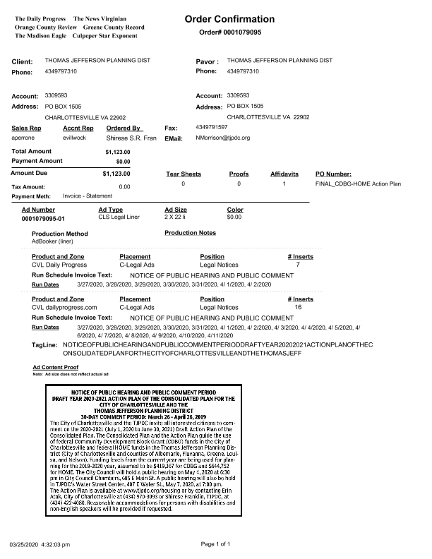
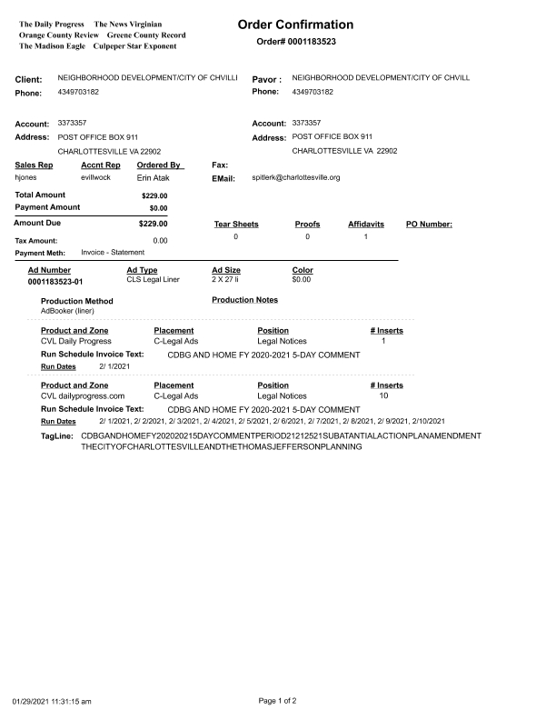
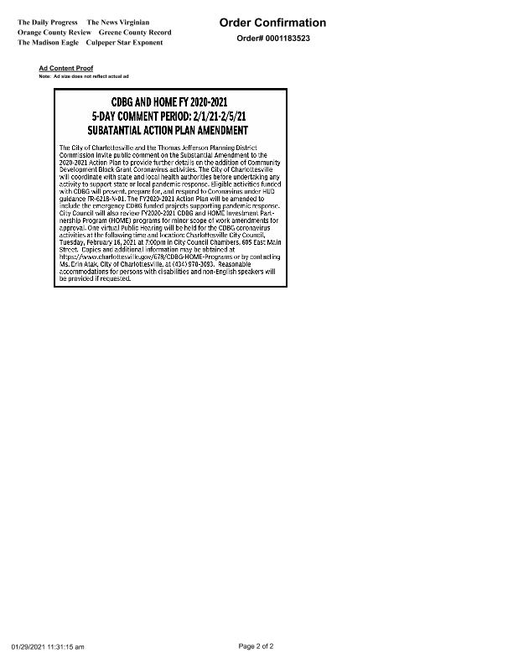
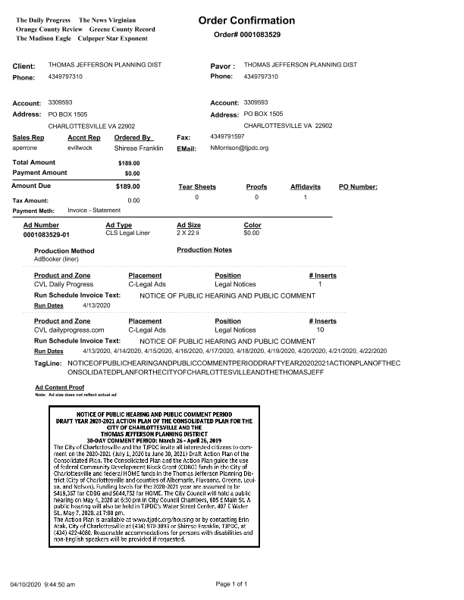
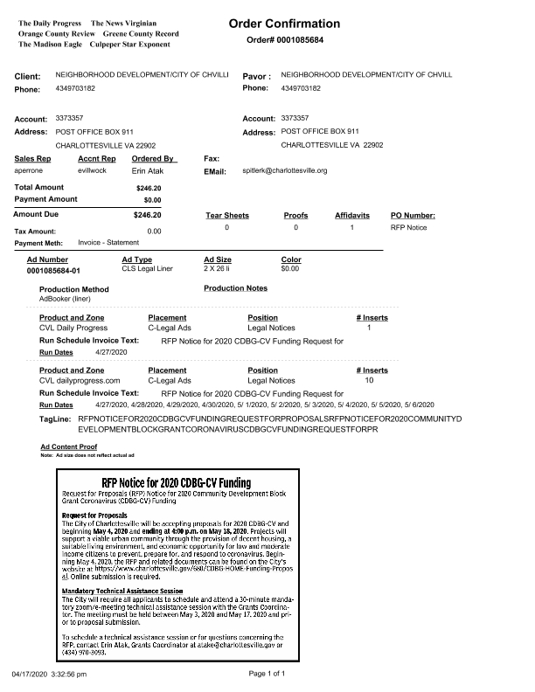
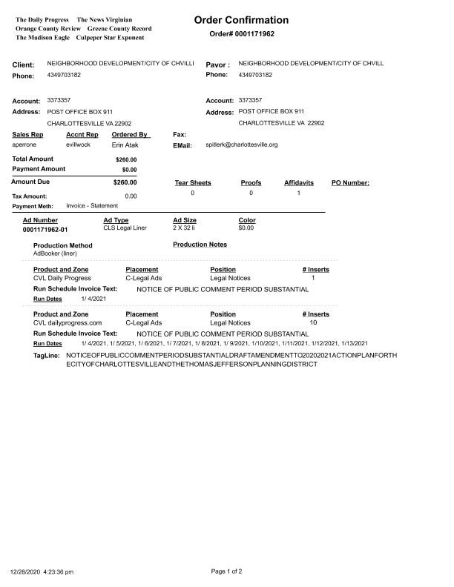
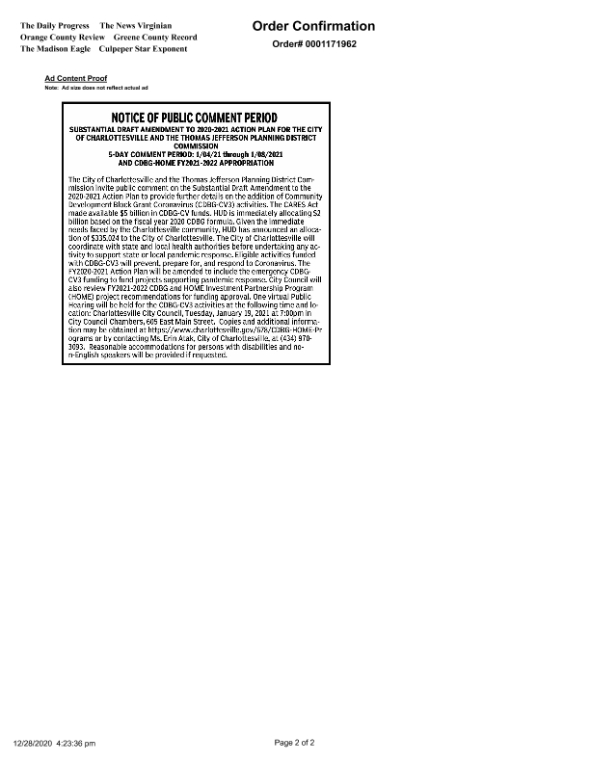
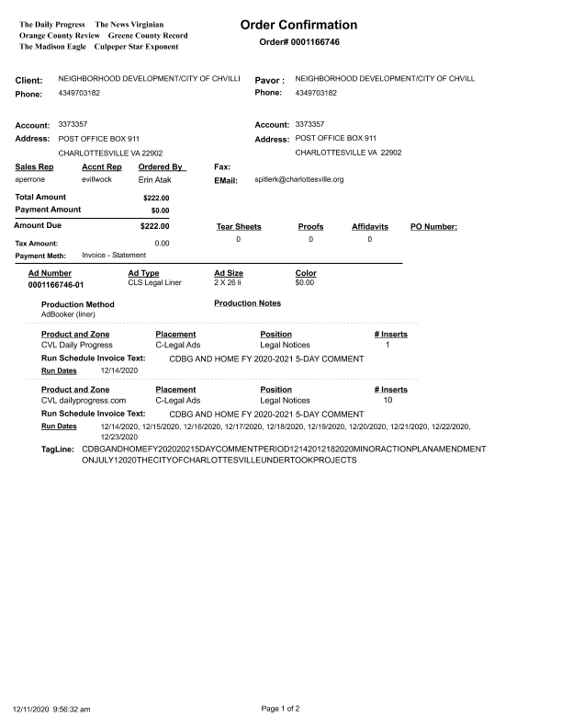
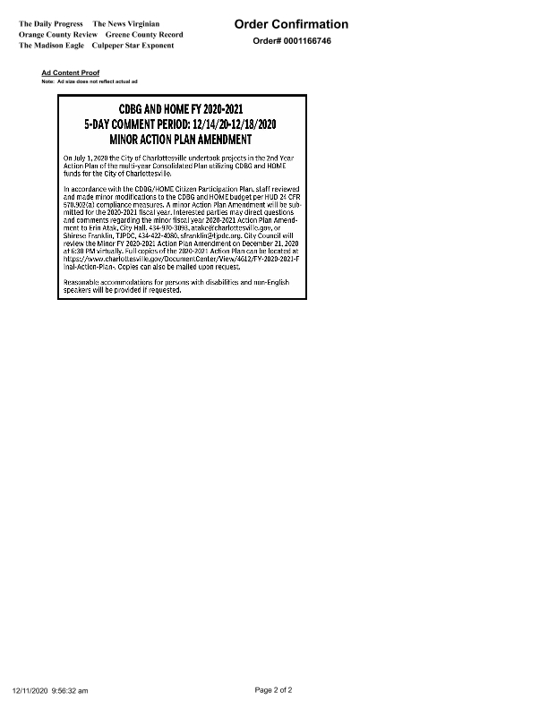
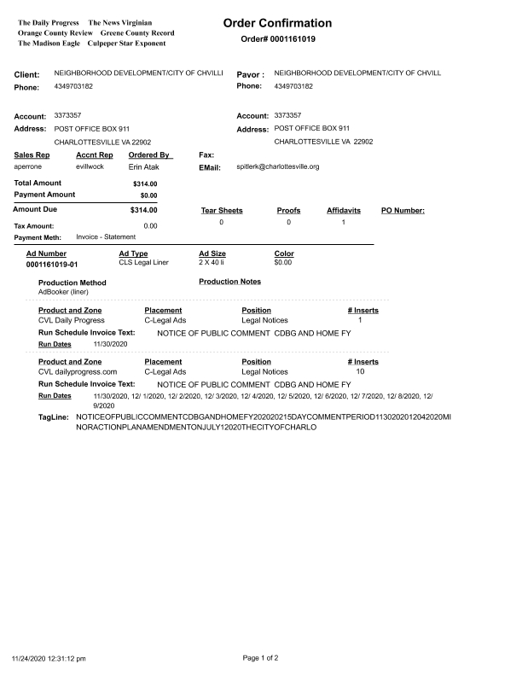
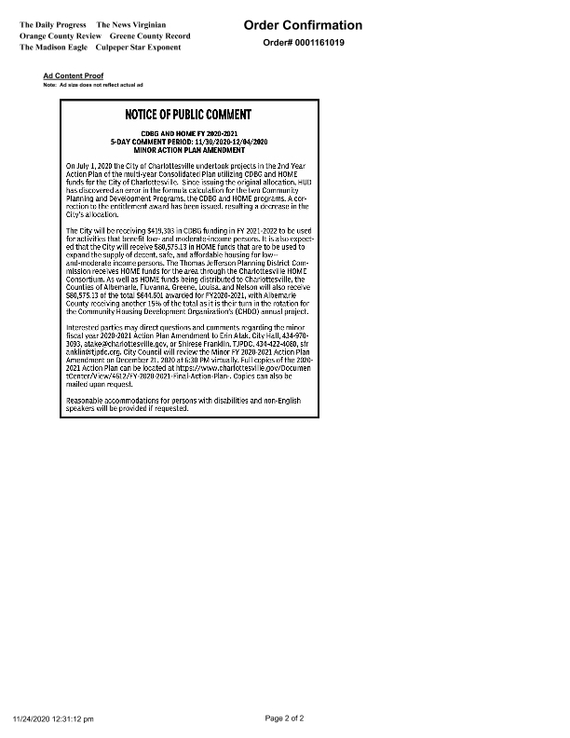
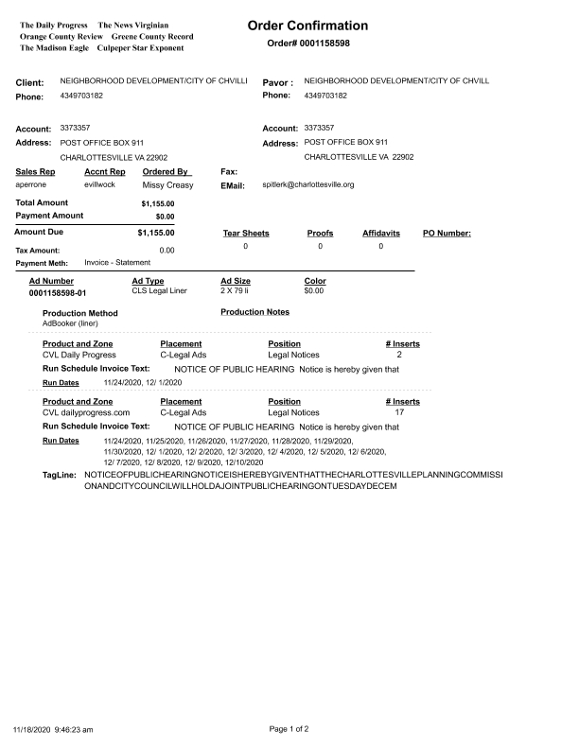
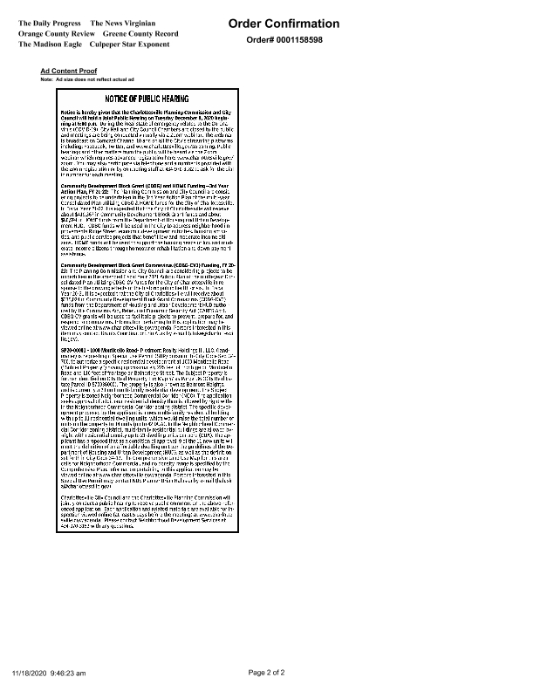
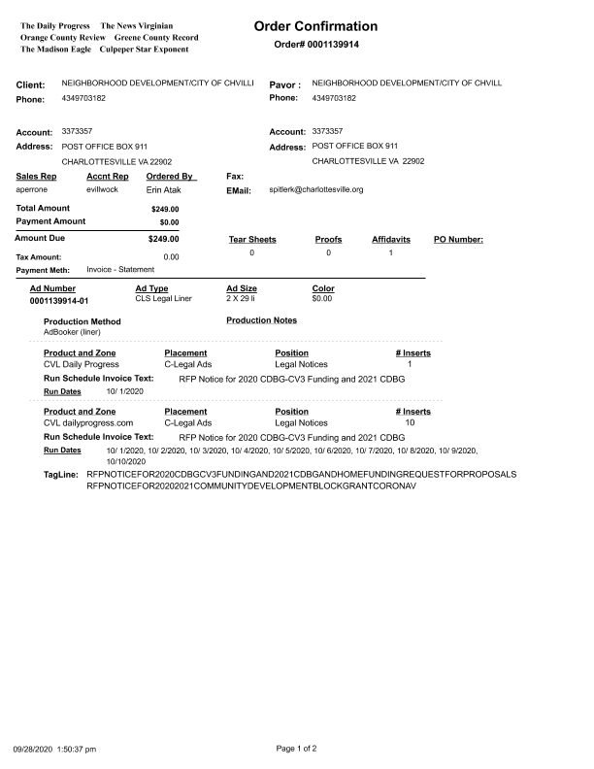
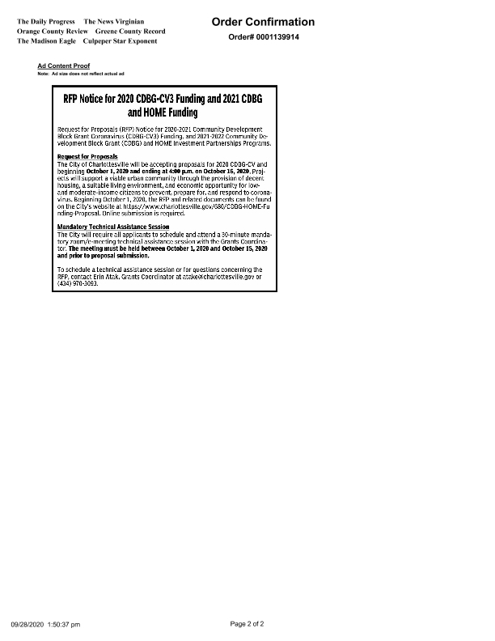

Grantee Unique Appendices
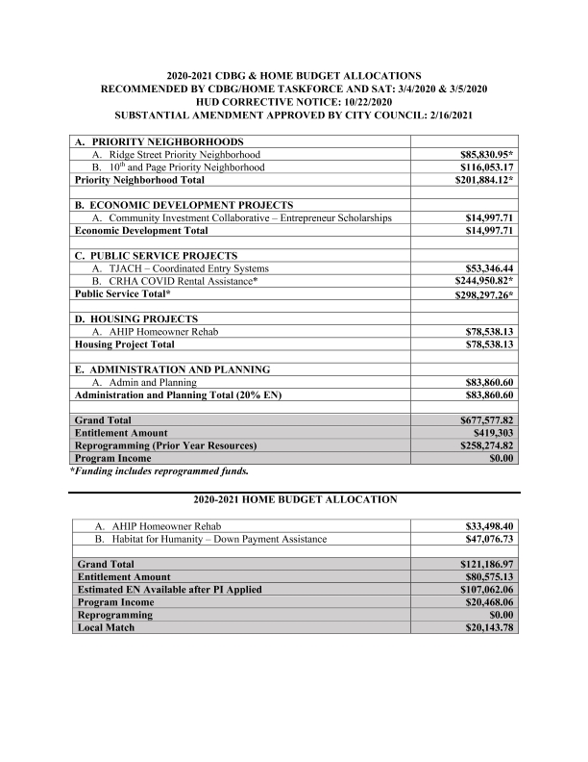
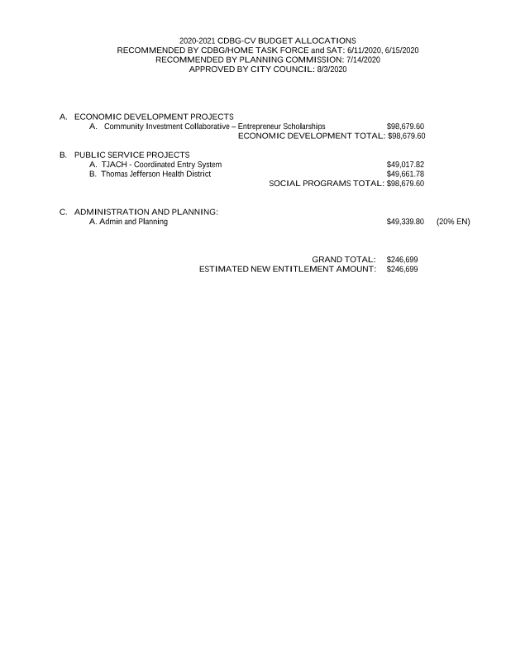
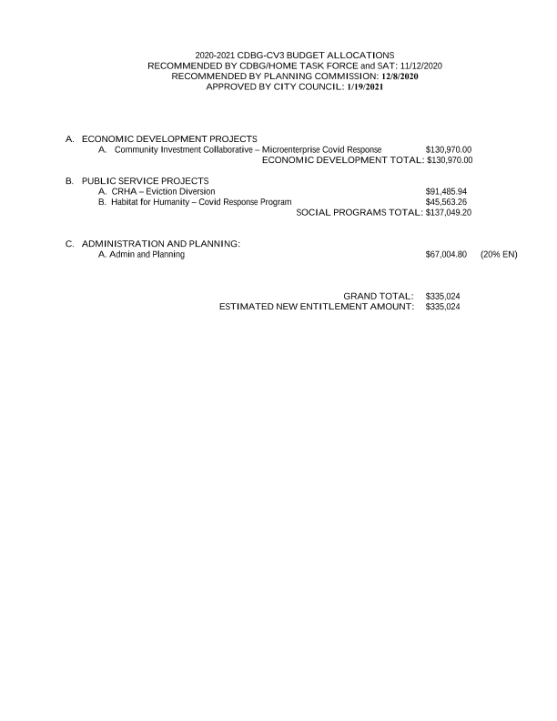
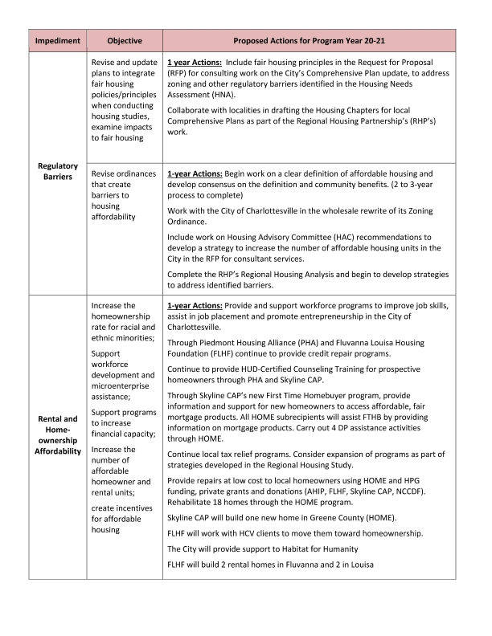
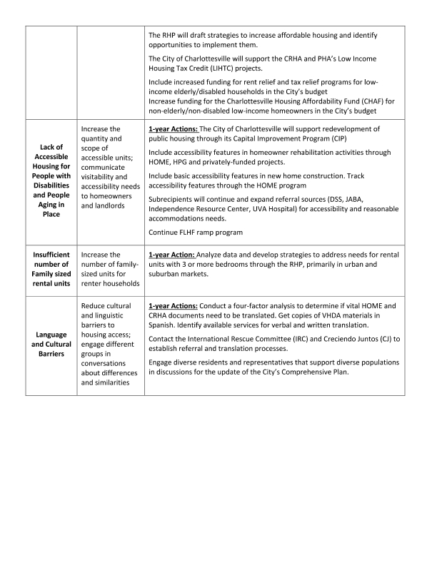
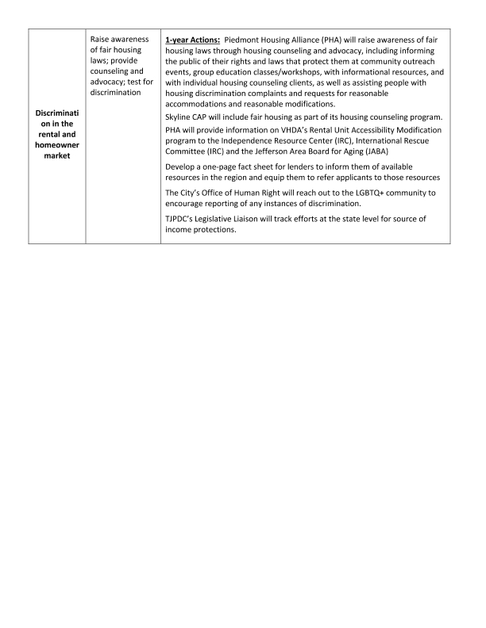
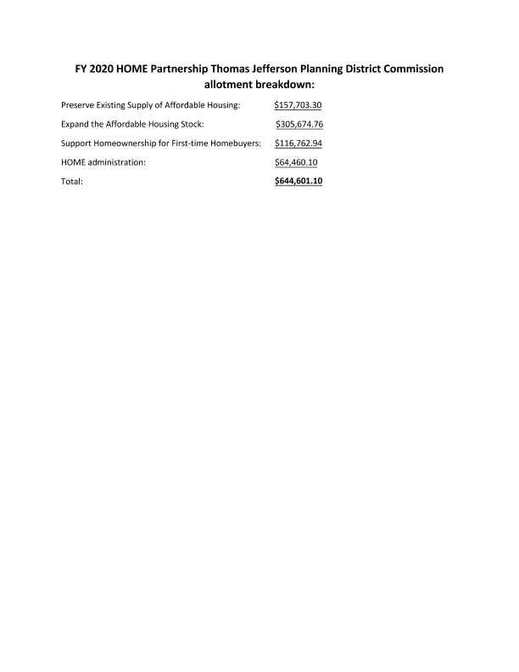

Grantee SF-424's and Certification(s)
